Final Project

for

IST769 – ADVANCED DATABASE MANAGEMENT SYSTEMS

by

Wenting Wang

A report submitted in partial fulfillment of the requirements for IST769

Submitted to

Susan Dischiave

On

12/8/2014

Wenting

157 Cambridge Street  
Syracuse, NY 13210

Contents

1. Problem Description 5

a. Business problem 5

▪ Industry 5

▪ Products/Services 5

▪ Decision-making 5

▪ Problems 5

▪ Decisions not made 6

b. Business Rules 6

2. Diagram 7

3. Tablespace 9

• Create tablespace 9

• Purpose of tablespace 10

4. Database 10

• Create database schema 10

• Schema owner 11

5. Roles 11

• Create roles 11

• Purpose of the roles 12

6. Profile 12

• Create profile 12

• Purpose of the profile 13

7. Uses 13

• Create users 13

• Why users were created were created the way they were? 14

8. Abstract Data Types 15

• Create abstract data types 15

• Why choose ADT for the event location attribute? 15

9. Tables 15

• Create tables 15

• The purpose of each table 23

• Insert data 24

10. Views 29

a. Event – Participants View 29

b. Book – Reviews View 30

11. Triggers 31

a. Event Registration Change trigger 31

Create trigger 31

Test trigger 32

b. Followingship Change Trigger 35

Create trigger 35

Test trigger 37

12. Packages 39

a. Package Definition 39

b. Package Body 41

c. Test Individual Procedures and Functions 44

1) BroadbeanPkg.FindAuthorIDFunc 44

2) BroadbeanPkg. FindBooksbySpecificAuthorFunc 46

3) BroadbeanPkg. FindISBNPro 48

4) BroadbeanPkg. FindCrewForSpecificMoviePro 50

13. Forms 51

a. Movie - Crew Form 51

Form Look 51

Create Form 52

b. Record – Performers Form 58

Form Look 58

Create form 58

c. Book - Reviews Form 62

Form Look 62

Create form 62

d. How do the forms help with the “decisions not made.” 65

14. Data 66

a. Movie - Crew Form 66

Input data 66

Test input 69

b. Record – Performer Form 71

Input data 71

Test input 73

c. Book - Review Form 74

Input data 74

Test input 77

15. Reports 78

a. Event & Participants Report 78

Create report 79

Paper layout 81

Web layout 81

b. Book & Reviews Report 82

Create report 83

Paper layout 85

Web layout 86

c. Report with parameters 86

d. How do these reports help answer the decisions that could not be made? 89

16. Backup/Recovery 89

a. Why choose specific methodology? 89

b. Cold backup procedure 90

c. Hot backup procedure 91

1) Place the database in ARCHIVELOG mode 91

d. Recover using a cold backup 91

f. recover using a hot backup 91

17. Performance/Tuning 91

a. Monitoring performance 91

1) Performance Monitoring using Enterprise Manager 91

2) Using SQL to Monitor Performance 94

b. Performance tuning 97

1) Tune Database Buffer Cache 97

2) Tune by Advisor Central 97

3) Tune by SQL 97

18. Lessons Learned 104



# 1. Problem Description

## a. Business problem

### Industry

As the social media evolves fast and people’s life became intimately related to social network, people are increasingly sharing everything on the website, among which movie, book and record reviews are no exception. Our company standing on the same footing with other social interactive website, but is more focused on sharing people’s interests in readings, music and movies.

### Products/Services

Our main product is an interactive website provided as a social platform for people to post reviews to books, movies and records and for them to follow each other and find common interests. Users can refer to our website to find information like how many people read this book, how is the average rating, etc., for example. Each individual item in movies, books and records is linked to other related website such as IMDB, Amazon and Pandora as well. Additionally, users can initiate and participate in an abundant variety of events and can also tell who will participate in a specific event.

### Decision-making

Currently, there exists no database for the purpose stated above. On the business side, we are not able to make any decisions at all because the whole idea of sharing interests relies upon enough amount of data collected from individual users and users are only able to access other users’ profiles after we construct a database solution to realize our envisioned website. On the user side, they can only refer to a bunch of other existing websites to look for movie, book and record reviews, why these reviews may be extensive in each category (book, movie or record), they would not be able to access other people’s interests in all of the categories all together. As an instance, users can’t tell what other movies, records a person is interested in when they found the same person posted certain reviews that attract them. Users would also not be able to see what type of events their friends attend, what books their friends read, and what movies their friends watch all on the same page at the same time.

### Problems

The information system would be able to solve the current problems by managing and maintaining user’s profile data, movie, book and record’s basic data, and user’s interactive data (like reviews, likes, event participations) in a central location. Then we can these separate data sets by building relationship among them. Hence we would be able to provide users with information like what books, movies and records other users. We would also be able to provide recommendations on books, movies and records based on users’ ratings and reviews. Moreover, we would enable users to organize events on our website and to access all the participants’ information.

### Decisions not made

There are some key business decisions we cannot make if we don’t have access to the right data.

1. How many people read a specific book, watched a specific movie or listened to a specific music record?
2. What books, movies and music records does a specific user likes?
3. How’s a specific book/movie/music record’s average rating?
4. What events attract the most participation? Who are participating these events?
5. How many users are following a specific user? What interest profile does the person have?

## b. Business Rules

1) A book/movie/record can be reviewed by zero to many users and one user can review many zero to many books/movies/music records.

(The relationship between book/movie/record and review is many to many, with the Reviews table constructed as an associate table.)

2) A user can follow zero to many users and a user can be followed by zero to many users.

(The relationship between users is many to many, with the Followingship table constructed as an associate table.)

3) An event must be organized by one user. A user can register in zero to multiple events and an event can be attended by one to multiple users.

(The OrganizerID in Event table is a foreign key reference the UserID in User table. The relationship between user and event is many to many, with the EventsRegistration table constructed as an associate table.)

4) In Reviews table, CategoryID stands for the category. It only has three possible values. ‘M’ stands for movie, ‘B’ stands for book, ‘R’ stands for record.

5) In Reviews table, CategoryNum is the unique identifier in the category specified by CategoryID.

(If the CategoryID is ‘B, then the CategoryNum is a foreign key reference the ISBN in Book table; If the CategoryID is ‘R’, then the CategoryNum is a foreign key reference the ISRC in Record table; If the CategoryID is ‘M’, then the CategoryNum is a foreign key reference the IMDBid in Movie table.)

6) In Reviews table, for each review record, there must be one user, who reviews for one and only one item of one of the three categories: Book, Movie and Record.

(In Review table, ReviewID is a surrogate key for the combination of UserID, CategoryID and CategoryNum).

7) RatedbyCount in Book/Movie/MusicRecord table is calculated by adding all of the user review records for the same Book/Movie/Record.

(Take Book table for example, it’s connected to the Reviews table via ISBN – CategoryNum. The RatedbyCount is calculated by adding all the review records with the CategoryID as ‘B’ and the same CategoryNum.)

8) BookRating/MovieRating/RecordRating is calculated as the average rating among all users who have given ratings to the same book/movie/record.

(Rating attribute in Reviews table has a value from 0.0 to 10.0, depends on how users like the specific book/movie/record.)

9 ) ParticipantsCount column in Event table is calculated by adding up the number of all the users who register in the same event.

(The Event table and the EventsRegistration table are connected via EventID. A trigger will be set up so that each time when an record is added, deleted or updated in the EventsRegistration table, the ParticipantsCount for the related event will be updated.)

10) UserName in Users table stands for user’s net name and should not contain space.

# 2. Diagram

**ERD - Music, Movie & Record Reviews Sharing System - Broadbean Inc. **

# 3. Tablespace

## Create tablespace

--Create tablespace--

CREATE SMALLFILE TABLESPACE Broadbean DATAFILE 'C:\app\Administrator\admin\orcl\FinalProject'

Size 100M

AUTOEXTEND ON NEXT 100k MAXSIZE UNLIMITED

NOLOGGING EXTENT MANAGEMENT LOCAL SEGMENT SPACE MANAGEMENT AUTO;

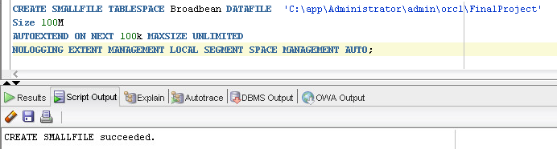

--Show all the tablespaces--

Select tablespace_name from dba_data_files;

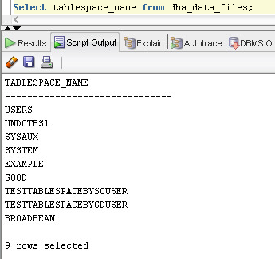

## Purpose of tablespace

Tablesapce is logical storage adopted by Oracle. Data is stored physically as datafiles which are associated with the corresponding tablespace. An Oracle database consists of one or more logical storage units called tablespaces, which collectively store all of the database's data. Each tablespace in an Oracle database consists of one or more files called datafiles, which are physical structures that conform to the operating system in which Oracle is running. A database's data is collectively stored in the datafiles that constitute each tablespace of the database. For example, the simplest Oracle database would have one tablespace and one datafile. Another database can have three tablespaces, each consisting of two datafiles (for a total of six datafiles).

The Tablespace is created to store all the data concerning Broad Inc.’s business. All the tables that related to the information system will be stored logically on this tablespace.

# 4. Database

## Create database schema

--Create database schema—

CREATE USER Broadbean IDENTIFIED BY IST769

DEFAULT TABLESPACE Broadbean

TEMPORARY TABLESPACE TEMP

QUOTA UNLIMITED ON Broadbean

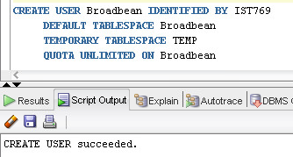

GRANT create session TO Broadbean;

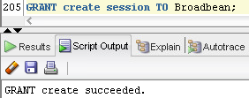

(Later I erroneously use the Schema as the user access and create all the tables, I have granted DBA privilege to the schema owner as well

GRANT DBA TO Broadbean;

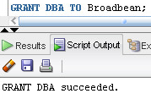)

## Schema owner

A schema is a collection of database objects, including logical structures created by users to contain, or reference, their data, such as tables, views, sequences, stored procedures, synonyms, indexes, clusters, and database links. We can create and manipulate schema objects using Oracle Enterprise Manager. The schema owner represents the Oracle user that owns all your database objects, while application users are Oracle users that need access to those schema objects.

# 5. Roles

## Create roles

--Create roles--

--Create regular user role—

CREATE ROLE BroadRegularUserRole;

GRANT CREATE TABLE, ALTER ANY TABLE, DROP ANY TABLE, CREATE VIEW, DROP ANY VIEW to BroadRegularUserRole WITH ADMIN OPTION;

GRANT OEM_MONITOR to BroadRegularUserRole;

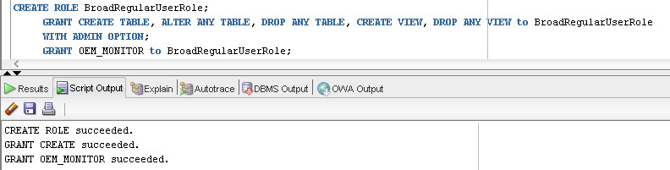

--Create user role with DBA privilege—

CREATE ROLE BroadDBARole;

GRANT CREATE SESSION, CREATE ROLE, CREATE USER, CREATE PROFILE, ALTER ANY ROLE, ALTER USER, ALTER PROFILE, DROP ANY ROLE, DROP USER, DROP PROFILE to BroadDBARole;

GRANT OEM_MONITOR, IMP_FULL_DATABASE, EXP_FULL_DATABASE to BroadDBARole;

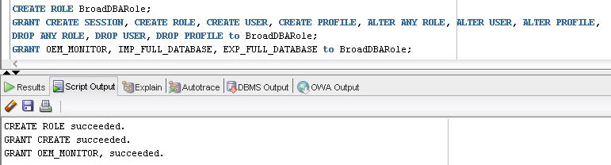

## Purpose of the roles

A role is a set of privileges that can be granted to users or to other roles. Regular user role is provided for users with non-DBA privileges. DBA role is for users with DBA privilege.

We created BroadRegularUserRole to provide basic privileges to regular users of the database. For example, the front-end engineer and application engineer users could be granted with this role.

We created BroadDBARole to provide DBA privileges to database administration users. For example, the database engineer and database administrator users in our company could be granted with this role.

# 6. Profile

## Create profile

--Create profile--

CREATE PROFILE BroadGeneralProfile LIMIT

SESSIONS_PER_USER 1 --Limit the user to user a maximum of 5 sessions

IDLE_TIME 5 --Limit the idle time to be no more than 5 minutes

FAILED_LOGIN_ATTEMPTS 3 --The account will be locked out after 3 failed attempts to log on

PASSWORD_LIFE_TIME 375 --The user must change their password after 12 months and 10 days

PASSWORD_REUSE_TIME 365 --Passwords can be reused after 1 year

PASSWORD_LOCK_TIME 0.125 --After the failed attempts, accounts will be locked out for 3 hours

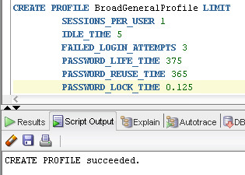

## Purpose of the profile

Profiles are a means to limit resources a user can use. It refers to a collection of attributes that apply to a user, enabling a single point of reference for any of multiple users that share those exact attributes. User profiles in Oracle Internet Directory contain a wide range of attributes pertinent to directory usage and authentication for each user. Before profiles can be assigned, they must be created with “CREATE PROFILE”. Then, they can be assigned to users with “Create user … Profile” or “Alter user … Profile”.

We crate this profile to limit the number of sessions a user can access simultaneously, limit the idle time a user can leave the screen and guarantee higher safety by ensuring password related policies. If the user entered wrong password by three times, the account is locked for a time period of PASSWORD_LOCK_TIME. The PASSWORD_RESUSE_TIME and the PASSWORD_LIFE_TIME specify that after how long a password can be reused and after how long a password must be reset respectively. We create this profile to ensure database security by solidifying user account authentification.

# 7. Uses

## Create users

--Create a user with DBA privilege—

CREATE USER BroadDBA IDENTIFIED BY IST769

Profile BroadGeneralProfile;

GRANT BroadDBARole to BroadDBA;

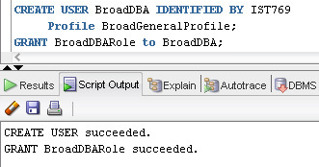

--Create a user with non-DBA privileges—

CREATE USER BroadRegular IDENTIFIED BY IST769

Profile BroadGeneralProfile;

GRANT BroadRegularUserRole to BroadDBA;

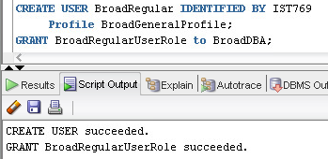

## Why users were created were created the way they were?

Users allow Oracle users to access to the schema objects. Each Oracle database has a list of valid database users. To access a database, a user must run a database application and connect to the database instance using a valid user name defined in the database. In creating a user, the IDENTIFIED clause lets you indicate how Oracle Database authenticates the user. DEFAULT TABLESPACE Clause specify the default tablespace for objects that the user creates. TEMPORARY TABLESPACE Clause specifies the tablespace or tablespace group for the user's temporary segments. QUOTA Clause specifies the maximum amount of space the user can allocate in the tablespace. PROFILE Clause specifies the profile you want to assign to the user. PASSWORD EXPIRE Clause specifies PASSWORD EXPIRE if you want the user's password to expire.

We create these two users to perform different tasks. Like we stated in the Role section. The first user could be front-end engineer or application engineer who will interact regularly with the database but not be allowed to make changes to the database. The second user is our database’s administrator.

# 8. Abstract Data Types

## Create abstract data types

--Create Abstract data type--

CREATE TYPE Broadbean.AddressADT AS OBJECT

(

addrHouseNum CHAR(10),

addrStreetName VARCHAR2(50),

addrAppt VARCHAR2(20)

);

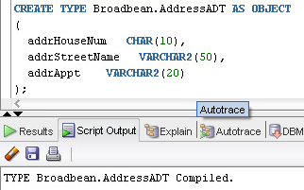

## Why choose ADT for the event location attribute?

Location include street name, house or apartment number, each segment, for example street can be used to identify specific section of the city. Some neighborhoods of the city may host most of the events. To separate the address into several segments allow statistics over different segments of the data.

# 9. Tables

## Create tables

--Create tables--

CREATE TABLE Broadbean.Language

(

LanguageID INTEGER PRIMARY KEY,

LanguageName VARCHAR2(30) NOT NULL

)

CREATE TABLE Broadbean.Country

(

CountryID INTEGER PRIMARY KEY,

CountryName VARCHAR2(30) NOT NULL

)

CREATE TABLE Broadbean.Publisher

(

PublisherID INTEGER PRIMARY KEY,

PublisherName VARCHAR2(30) NOT NULL

)

CREATE TABLE Broadbean.Author

(

AuthorID INTEGER PRIMARY KEY,

FName VARCHAR2(30) NOT NULL,

LName VARCHAR2(30) NOT NULL,

AuthorBio VARCHAR2(50)

)

CREATE TABLE Broadbean.Performer

(

PerformerID INTEGER PRIMARY KEY,

FName VARCHAR2(30) NOT NULL,

LName VARCHAR2(30) NOT NULL,

PerformerBio VARCHAR2(50)

)

CREATE TABLE Broadbean.Crew

(

CrewID INTEGER PRIMARY KEY,

FName VARCHAR2(30) NOT NULL,

LName VARCHAR2(30) NOT NULL,

CrewBio VARCHAR2(50)

)

CREATE TABLE Broadbean.Role

(

RoleType VARCHAR2(20) PRIMARY KEY,

RoleDesc VARCHAR2(50)

);

CREATE TABLE Broadbean.Users

(

UserID INTEGER PRIMARY KEY,

UserName VARCHAR2(20),

Password CHAR(10),

RegisteredEmail VARCHAR2(20),

FollowedByCount INTEGER,

FollowsCount INTEGER

);

CREATE TABLE Broadbean.EventCategory

(

CategoryID INTEGER PRIMARY KEY,

CategoryName VARCHAR2(30) NOT NULL

);

CREATE TABLE Broadbean.Followingship

(

UserID INTEGER,

FollowerID INTEGER ,

StartTime DATE,

CONSTRAINT FollowingshipPK PRIMARY KEY (UserID, FollowerID),

CONSTRAINT FollowingshipFK1 FOREIGN KEY (UserID) REFERENCES Broadbean.Users (UserID),

CONSTRAINT FollowingshipFK2 FOREIGN KEY (FollowerID) REFERENCES Broadbean.Users(UserID)

);

CREATE TABLE Broadbean.Event

(

EventID INTEGER PRIMARY KEY,

EventName VARCHAR2(30) ,

EventLocation Broadbean.AddressADT,

OrganizerID INTEGER,

EventCategoryID INTEGER,

Fee DECIMAL(10,2) CHECK(Fee>=0),

EventETime DATE,

ParticipantsCount INTEGER,

CONSTRAINT EventFK1 FOREIGN KEY (OrganizerID) REFERENCES Broadbean.Users(UserID),

CONSTRAINT EventFK2 FOREIGN KEY (EventCategoryID) REFERENCES Broadbean.EventCategory(CategoryID)

);

CREATE TABLE Broadbean.EventsRegistration

(

RegistrationID INTEGER PRIMARY KEY,

EventID INTEGER NOT NULL ,

UserID INTEGER NOT NULL,

CONSTRAINT EventsRegistrationFK1 FOREIGN KEY (UserID) REFERENCES Broadbean.Users (UserID),

CONSTRAINT EventsRegistrationFK2 FOREIGN KEY (EventID) REFERENCES Broadbean.Event (EventID)

);

CREATE TABLE Broadbean.Book

(

ISBN INTEGER PRIMARY KEY,

BookName VARCHAR2(30) NOT NULL,

PublisherID INTEGER,

PublishingDate DATE,

LanguageID INTEGER,

BookRating DECIMAL(10,2),

RatebyCount INTEGER,

CONSTRAINT BookFK1 FOREIGN KEY (PublisherID) REFERENCES Broadbean.Publisher(PublisherID),

CONSTRAINT BookFK2 FOREIGN KEY (LanguageID) REFERENCES Broadbean.Language(LanguageID)

);

CREATE TABLE Broadbean.BookAuthor

(

BookID INTEGER,

AuthorID INTEGER,

CONSTRAINT BookAuthorPK PRIMARY KEY (BookID, AuthorID),

CONSTRAINT BookAuthorFK1 FOREIGN KEY (BookID) REFERENCES Broadbean.Book(ISBN),

CONSTRAINT BookAuthorFK2 FOREIGN KEY (AuthorID) REFERENCES Broadbean.Author(AuthorID)

);

CREATE TABLE Broadbean.Movie

(

IMDBid INTEGER PRIMARY KEY,

MovieName VARCHAR2(30) NOT NULL,

ReleaseDate DATE,

CountryID INTEGER,

LanguageID INTEGER,

MovieRating DECIMAL(10,2),

RatebyCount INTEGER,

CONSTRAINT MovieFK1 FOREIGN KEY (LanguageID) REFERENCES Broadbean.Language(LanguageID),

CONSTRAINT MovieFK2 FOREIGN KEY (CountryID) REFERENCES Broadbean.Country(CountryID)

);

CREATE TABLE Broadbean.MovieCrew

(

MovieID INTEGER,

CrewID INTEGER,

CrewRole VARCHAR(20),

CONSTRAINT MovieStarPK PRIMARY KEY (MovieID, CrewID),

CONSTRAINT MovieStarFK1 FOREIGN KEY (MovieID) REFERENCES Broadbean.Movie(IMDBid),

CONSTRAINT MovieStarFK2 FOREIGN KEY (CrewID) REFERENCES Broadbean.Crew(CrewID),

CONSTRAINT MovieStarFK3 FOREIGN KEY (CrewRole) REFERENCES Broadbean.Role(RoleType)

);

CREATE TABLE Broadbean.Record

(

ISRC INTEGER PRIMARY KEY,

Title VARCHAR2(30) NOT NULL,

ReleaseDate DATE,

RecordRating DECIMAL(10,2),

RatebyCount INTEGER

);

CREATE TABLE Broadbean.RecordPerformer

(

RecordID INTEGER,

PerformerID INTEGER,

CONSTRAINT RecordPerformerPK PRIMARY KEY (RecordID, PerformerID),

CONSTRAINT RecordPerformerFK1 FOREIGN KEY (RecordID) REFERENCES Broadbean.Record(ISRC),

CONSTRAINT RecordPerformerFK2 FOREIGN KEY (PerformerID) REFERENCES Broadbean.Performer(PerformerID)

)

CREATE TABLE Broadbean.Reviews

(

ReviewID INTEGER,

UserID INTEGER,

CategoryID CHAR(1),

CategoryNum INTEGER,

ReviewNote VARCHAR2(200),

Rating DECIMAL(10, 2),

CONSTRAINT ReviewsPK PRIMARY KEY (ReviewID),

CONSTRAINT ReviewsFK1 FOREIGN KEY (UserID) REFERENCES Broadbean.Users(UserID),

CONSTRAINT CategoryIDCheckVal CHECK (CategoryID = 'B' OR CategoryID = 'M' OR CategoryID = 'R')

);

drop TABLE Broadbean Reviews;

drop TABLE Broadbean.RecordPerformer;

drop TABLE Broadbean.Record;

drop TABLE Broadbean.MovieCrew;

drop TABLE Broadbean.Movie;

drop TABLE Broadbean.BookAuthor;

drop TABLE Broadbean.Book;

drop TABLE Broadbean.EventsRegistration;

drop TABLE Broadbean.Event;

drop TABLE Broadbean.Followingship;

drop TABLE Broadbean.EventCategory;

drop TABLE Broadbean.Users;

drop TABLE Broadbean.Role;

drop TABLE Broadbean.Crew;

drop TABLE Broadbean.Performer;

drop TABLE Broadbean.Author;

drop TABLE Broadbean.Publisher;

drop TABLE Broadbean.Country;

drop TABLE Broadbean.Language;

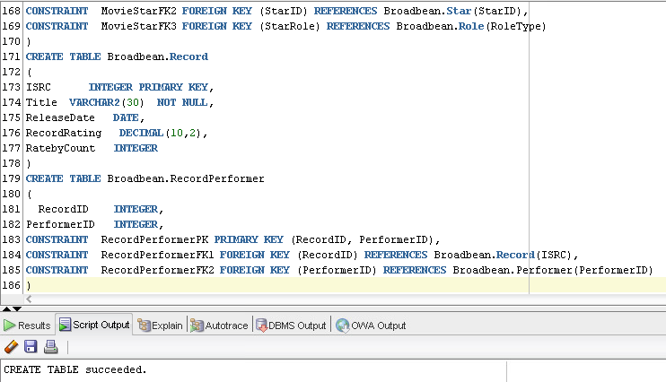

Table created:

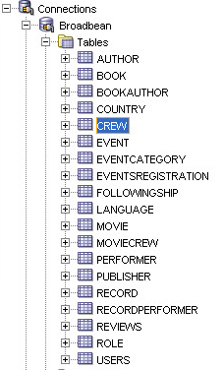

## The purpose of each table

Book, Movie, Record: To display general information about each item. For example, Book table contains information about book name, publisher id, publishing date, language, etc. Movie table contains information about movie name, director, releasing date, country, language, etc. Record table include information about record title, releasing date, etc.

Reviews: To display information about user’s review for each item in Book, Movie, Record. Review table includes information about which user gives the review, which specific item the review is related to, the content of the review and the rating number.

Author, Star, Performer: To display general information about the creators/participants of Book, Movie and Record. For example, Author table contains information about Author’s name, bio. Star table contains Star’s name, bio. Performer table contains information about Performer’s name bio, etc.

Country, Language: To normalize the database tables, contain information about Country Name, Language name respectively.

BookAuthor, MovieStar, RecordPerformer: contain information about the relationship between Book/Movie/Record and their creators/participants.

User: To show information about specific users, includes user name, password(encrypted), registering email, etc.

Followingship: A table to show the relationships (being followed or following others) between users.

Event: A table to store the general information of an event, including event name, location, event category, fee, time, etc.

EventRegistration: A table to record user’s registration in specific events. Event ID and User ID are recorded for each record in this table.

EventCategory: Is used to keep track of the categories of events, for example, entertainment events, sports events, academic events, etc.

## Insert data

INSERT INTO Broadbean.Language VALUES(1000, 'English');

INSERT INTO Broadbean.Language VALUES(1001, 'Chinese');

INSERT INTO Broadbean.Language VALUES(1002, 'French');

INSERT INTO Broadbean.Language VALUES(1003, 'Japanese');

INSERT INTO Broadbean.Language VALUES(1004, 'Spanish');

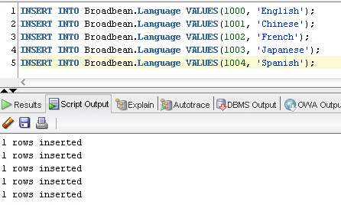

INSERT INTO Broadbean.Country VALUES(2000, 'American');

INSERT INTO Broadbean.Country VALUES(2001, 'England');

INSERT INTO Broadbean.Country VALUES(2002, 'France');

INSERT INTO Broadbean.Country VALUES(2003, 'Japan');

INSERT INTO Broadbean.Country VALUES(2004, 'China');

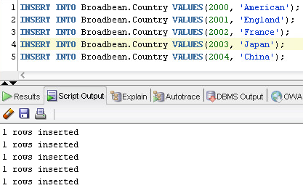

INSERT INTO Broadbean.Publisher VALUES(10000, 'ThomsonReuters');

INSERT INTO Broadbean.Publisher VALUES(10001, 'Hachette Livre');

INSERT INTO Broadbean.Publisher VALUES(10002, 'Pearson');

INSERT INTO Broadbean.Publisher VALUES(10003, 'Shueisha');

INSERT INTO Broadbean.Publisher VALUES(10004, 'Phoneix');

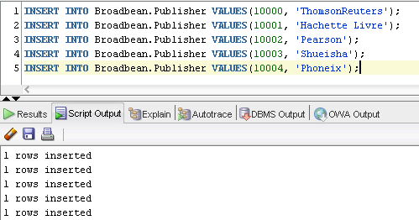

INSERT INTO Broadbean.Author VALUES(100000000, 'John', 'Almon','');

INSERT INTO Broadbean.Author VALUES(100000001, 'Robert', 'Bolt', '');

INSERT INTO Broadbean.Author VALUES(100000002, 'Pierre', 'Bottero', '');

INSERT INTO Broadbean.Author VALUES(100000003, 'Yan', 'Mo', '');

INSERT INTO Broadbean.Author VALUES(100000004, 'Haruki', 'Murakami', '');

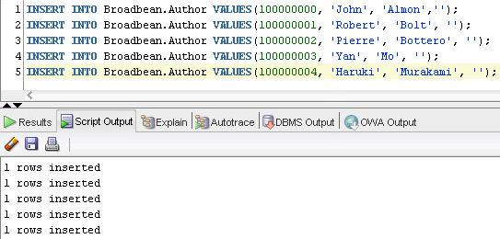

INSERT INTO Broadbean.Performer VALUES(200000000, 'John', 'Lennon','');

INSERT INTO Broadbean.Performer VALUES(200000001, 'Jian', 'Cui', '');

INSERT INTO Broadbean.Performer VALUES(200000002, 'Karen', 'Ann', '');

INSERT INTO Broadbean.Performer VALUES(200000003, 'Yan', 'Mo', '');

INSERT INTO Broadbean.Performer VALUES(200000004, 'Toshio', 'Nakanishi', '');

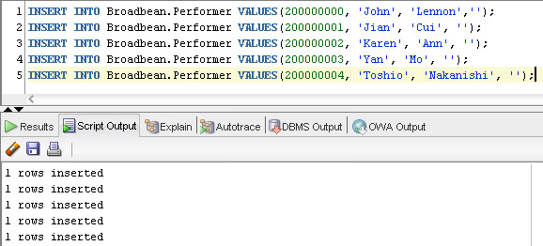

INSERT INTO Broadbean.Crew VALUES(300000000, 'Tom', 'Hanks','');

INSERT INTO Broadbean.Crew VALUES(300000001, 'Nicole', 'Kidman', '');

INSERT INTO Broadbean.Crew VALUES(300000002, 'Ken', 'Takakura', '');

INSERT INTO Broadbean.Crew VALUES(300000003, 'Jack', 'Nicholson', '');

INSERT INTO Broadbean.Crew VALUES(300000004, 'Alain', 'Delon', '');

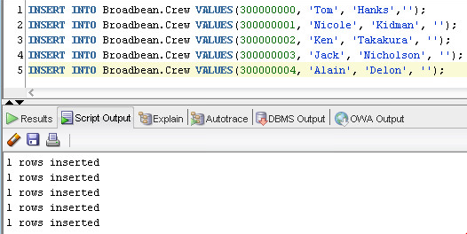

INSERT INTO Broadbean.Role VALUES('Actor', 'A person portraying a character');

INSERT INTO Broadbean.Role VALUES('Actress', 'A person portraying a character');

INSERT INTO Broadbean.Role VALUES('Director', 'A person who directs the making of a film');

INSERT INTO Broadbean.Role VALUES('Photographer', 'A person who takes photographs');

INSERT INTO Broadbean.Role VALUES('Audio Engineer', 'A person who takes care of sound');

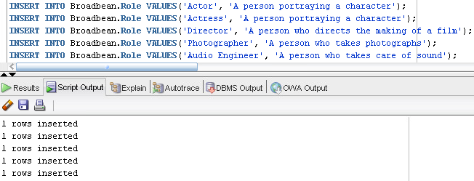

INSERT INTO Broadbean.Users VALUES(1000000001, 'Erik', 'IST769', 'Erik@gmail.com', 5, 6);

INSERT INTO Broadbean.Users VALUES(1000000002, 'Gross', 'IST769','Gross@gmail.com', 5, 5);

INSERT INTO Broadbean.Users VALUES(1000000003, 'Spek', 'IST769','Spek@gmail.com', 4, 3);

INSERT INTO Broadbean.Users VALUES(1000000004, 'Ido', 'IST769','Ido@gmail.com', 5, 2);

INSERT INTO Broadbean.Users VALUES(1000000005, 'Rwa', 'IST769','Rwa@gmail.com', 2, 1);

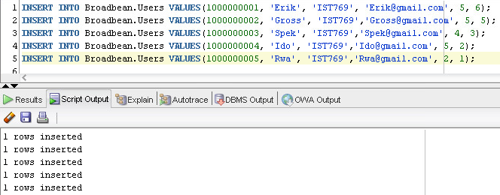

INSERT INTO Broadbean.EventCategory VALUES(100, 'Entertainment');

INSERT INTO Broadbean.EventCategory VALUES(101, 'Sports');

INSERT INTO Broadbean.EventCategory VALUES(102, 'Movie');

INSERT INTO Broadbean.EventCategory VALUES(103, 'Social');

INSERT INTO Broadbean.EventCategory VALUES(104, 'Psychology');

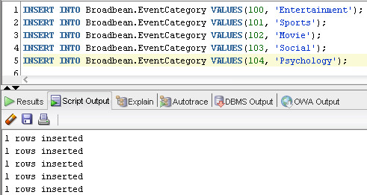

INSERT INTO Broadbean.Followingship VALUES(1000000001,1000000002, '21-Apr-2011');

INSERT INTO Broadbean.Followingship VALUES(1000000001,1000000003, '01-May-2011');

INSERT INTO Broadbean.Followingship VALUES(1000000002,1000000001, '16-Aug-2011');

INSERT INTO Broadbean.Followingship VALUES(1000000002,1000000005, '30-Sep-2011');

INSERT INTO Broadbean.Followingship VALUES(1000000003,1000000004, '15-Feb-2011');

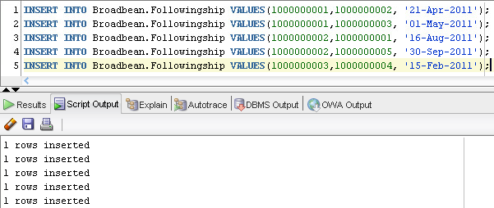

INSERT INTO Broadbean.Event VALUES(30000001, 'Hike at Green Lakes', Broadbean.AddressADT('7580-7676', 'Route 290', ''), 1000000001, 101, 3.0, '07-Dec-2014', 0);

INSERT INTO Broadbean.Event VALUES(30000002, 'Italian Movies', Broadbean.AddressADT('1003', 'West Fayette Street', ''), 1000000002, 102, 10.0, '08-Dec-2014', 0);

INSERT INTO Broadbean.Event VALUES(30000003, 'Cafe Conversation', Broadbean.AddressADT('115', 'Solar Street', '101'), 1000000001, 103, 0.0, '13-Dec-2014', 0);

INSERT INTO Broadbean.Event VALUES(30000004, 'Trivia Tuesdays', Broadbean.AddressADT('201', 'Ulster Street', ''), 1000000003, 103, 5.0, '16-Dec-2014', 0);

INSERT INTO Broadbean.Event VALUES(30000005, 'Core Strength Yoga', Broadbean.AddressADT('1003', 'West Fayette Street', ''), 1000000002, 101, 15.0, '07-Dec-2014', 0);

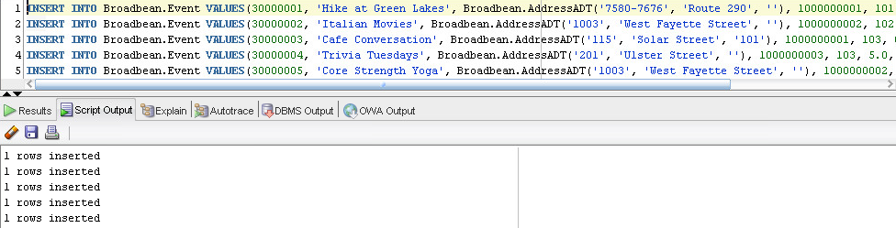

# 10. Views

## a. Event – Participants View

---1.EventParticipants_View: To address the ADT type in Event type, create this view to retrieve information about events---

---and their respective participants information---

create view Broadbean.EventParticipants_View as

select e.EventID, e.EventName, e.EventLocation.addrHouseNum EventHouseNum, e.EventLocation.addrStreetName EventStreetName, e.EventLocation.addrAppt EventAppt, u1.UserName OrganizerName, e.Fee, e.EventeTime, e.participantscount, ec.CategoryName EventCategory, u.UserID, u.UserName, u.RegisteredEmail, u.FollowedByCount, u.FollowsCount from Broadbean.Users u1 right join Broadbean.Event e on e.OrganizerID = u1.UserID left join Broadbean.EventsRegistration er on e.EventID = er.EventID left join Broadbean.Users u on er.UserID = u.UserID left join Broadbean.EventCategory ec on e.EventCategoryID = ec.CategoryID;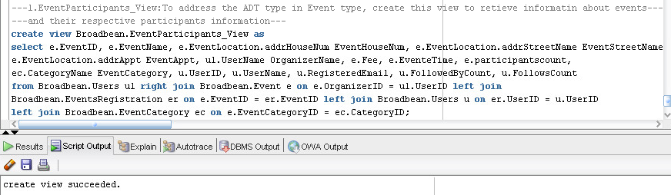

## b. Book – Reviews View

---2.BookReviews_View: To retrieve information about books and reviews for each book---

create view BookReviews_View as

select b.ISBN, b.BookName, p.PublisherName, b.PublishingDate, l.LanguageName, b.BookRating, r.reviewid, u.username,

r.reviewnote, r.rating from Book b join Reviews r on b.ISBN = r.CategoryNum and r.CategoryID = 'B' join Users u on r.UserID = u.UserID

join Publisher p on b.PublisherID = p.PublisherID join Language l on b.LanguageID = l.LanguageID;

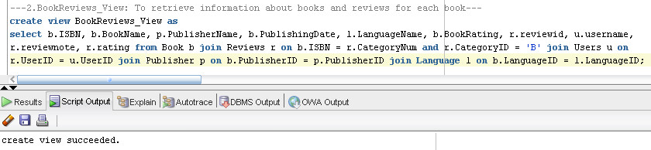

# 11. Triggers

## a. Event Registration Change trigger

The purpose of this trigger is to update the participantsCount for that event when there is a new user register for an event.

### Create trigger

---1. Create event participation count trigger which changes participation count when there is new registration or cancelled registration for an event---

CREATE OR REPLACE TRIGGER BroadBean.EventRegistrationChange

BEFORE insert or update or delete of EventID on BroadBean.EventsRegistration

FOR EACH ROW

BEGIN

if INSERTING THEN

UPDATE BroadBean.Event set ParticipantsCount = ParticipantsCount + 1 where BroadBean.Event.EventID = :new.EventID;

end if;

if UPDATING THEN

UPDATE BroadBean.Event set ParticipantsCount = ParticipantsCount + 1 where BroadBean.Event.EventID = :new.EventID;

UPDATE BroadBean.Event set ParticipantsCount = ParticipantsCount - 1 where BroadBean.Event.EventID = :old.EventID;

end if;

if DELETING THEN

UPDATE BroadBean.Event set ParticipantsCount = ParticipantsCount - 1 where BroadBean.Event.EventID = :old.EventID;

end if;

END;

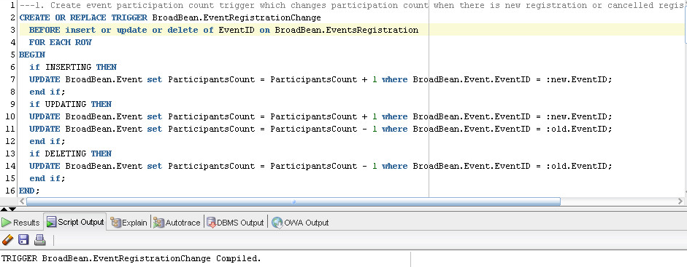

### Test trigger

Before insert any record into BroadBean.EventsRegistration Table:

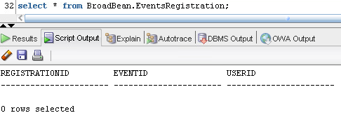

After insert a record into BroadBean.EventsRegistration Table:

---Create a sequence for automatically increasing the primary key for EventsRegistration---

CREATE SEQUENCE RegistrationID_SEQ

Start with 40000000000

Increment by 1

Cache 100;

---Insert a record into to test the EventRegistrationChange trigger---

insert into BroadBean.EventsRegistration values(RegistrationID_SEQ.NEXTVAL, 30000001, 1000000001);

select * from BroadBean.Event;

select * from BroadBean.Users;

select * from good.orderdetail;

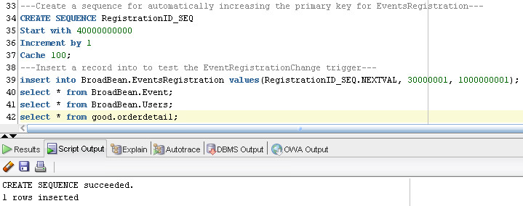

Now we can see the participation count has been updated for Event 30000001, which is shown in the image below.

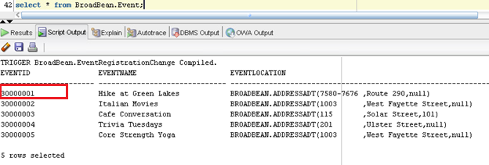

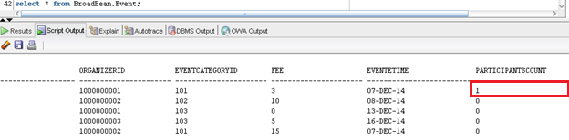

Insert more records:

insert into BroadBean.EventsRegistration values(RegistrationID_SEQ.NEXTVAL, 30000002, 1000000001);

insert into BroadBean.EventsRegistration values(RegistrationID_SEQ.NEXTVAL, 30000002, 1000000003);

insert into BroadBean.EventsRegistration values(RegistrationID_SEQ.NEXTVAL, 30000003, 1000000002);

insert into BroadBean.EventsRegistration values(RegistrationID_SEQ.NEXTVAL, 30000003, 1000000004);

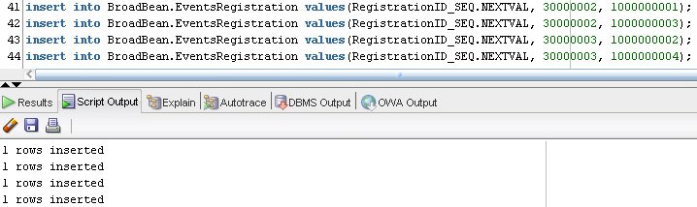

The EventRegistrationChange trigger is in effect, as show in the following screenshot:

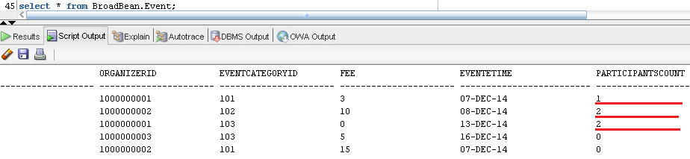

If we delete a row from BroadBean.EventsRegistration table:

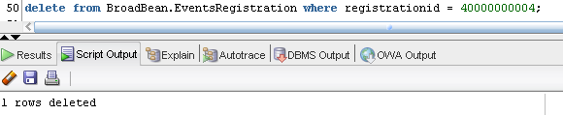

The participation count is automatically updated for that specific event:

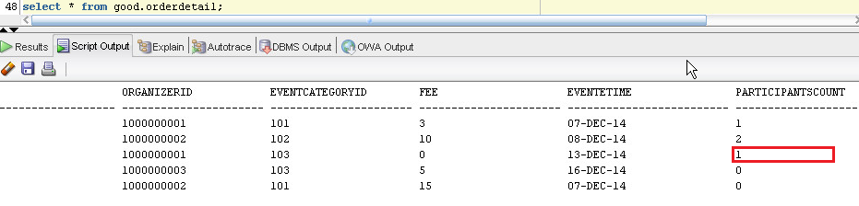

After updating a row in BroadBean.EventsRegistration table:

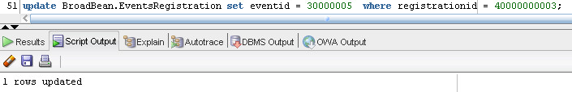

The participation count is automatically updated for that relevant events:

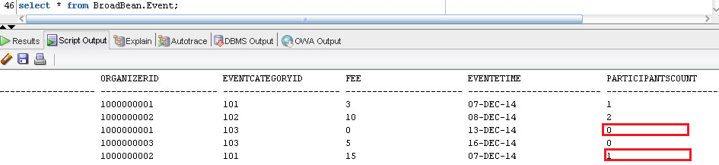

Before we create the second trigger, let’s update the values of followscount and followedbycount to 0 for Users table (which serves as the initial condition for these two columns).

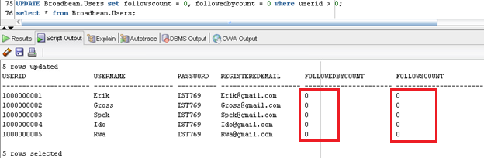

## b. Followingship Change Trigger

The purpose of this trigger is to update the FollowedByCount or FollowsCount for relevant users when any following relationship changes.

### Create trigger

Create the FollowingshipChange trigger:

---2. Create user followingship count trigger which changes FollowedByCount or FollowsCount for Users table when change is detected in Followingship Table---

CREATE OR REPLACE TRIGGER BroadBean.FollowingshipChange

BEFORE insert or update or delete of UserID or insert or update or delete of FollowerID on BroadBean.Followingship

FOR EACH ROW

BEGIN

if INSERTING THEN

UPDATE BroadBean.Users set FollowsCount = FollowsCount + 1 where BroadBean.Users.UserID = :new.FollowerID;

UPDATE BroadBean.Users set FollowedbyCount = FollowedbyCount + 1 where BroadBean.Users.UserID = :new.UserID;

end if;

if UPDATING THEN

UPDATE BroadBean.Users set FollowsCount = FollowsCount + 1 where BroadBean.Users.UserID = :new.FollowerID;

UPDATE BroadBean.Users set FollowedbyCount = FollowedbyCount + 1 where BroadBean.Users.UserID = :new.UserID;

UPDATE BroadBean.Users set FollowsCount = FollowsCount - 1 where BroadBean.Users.UserID = :old.FollowerID;

UPDATE BroadBean.Users set FollowedbyCount = FollowedbyCount - 1 where BroadBean.Users.UserID = :old.UserID;

end if;

if DELETING THEN

UPDATE BroadBean.Users set FollowsCount = FollowsCount - 1 where BroadBean.Users.UserID = :old.FollowerID;

UPDATE BroadBean.Users set FollowedbyCount = FollowedbyCount - 1 where BroadBean.Users.UserID = :old.UserID;

end if;

END;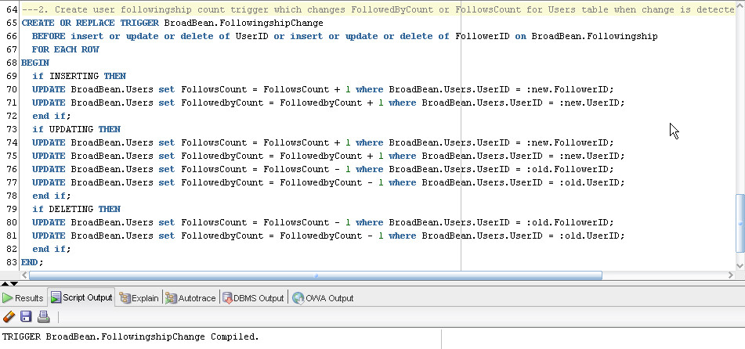

### Test trigger

After inserting data into Broadbean.Followingship table:

INSERT INTO Broadbean.Followingship VALUES(1000000001,1000000002, '21-Apr-2011');

INSERT INTO Broadbean.Followingship VALUES(1000000001,1000000003, '01-May-2011');

INSERT INTO Broadbean.Followingship VALUES(1000000002,1000000001, '16-Aug-2011');

INSERT INTO Broadbean.Followingship VALUES(1000000002,1000000005, '30-Sep-2011');

INSERT INTO Broadbean.Followingship VALUES(1000000003,1000000004, '15-Feb-2011');

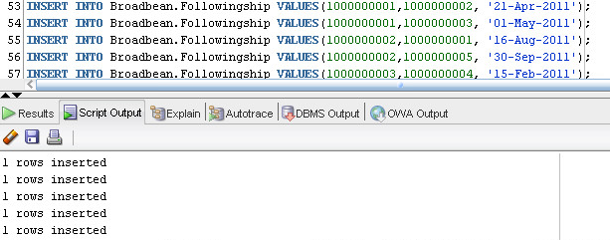

The FollowedByCount and FollowsCount for Boradbean.users table are automatically updated

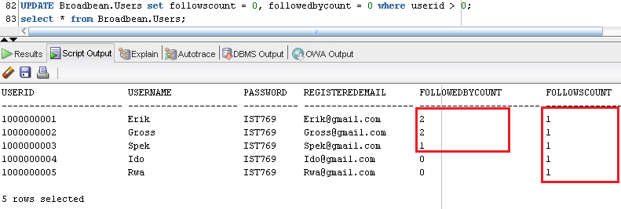

After deleting a row in Broadbean.Followingship table:

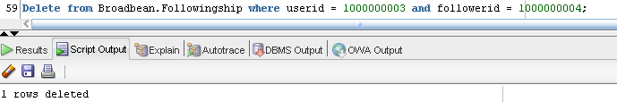

The FollowedByCount and FollowsCount for Boradbean.users table are automatically updated

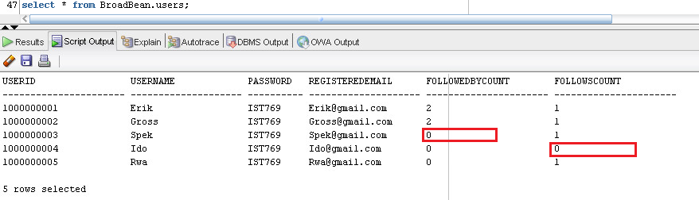

After updating a row in Broadbean.Followingship table:

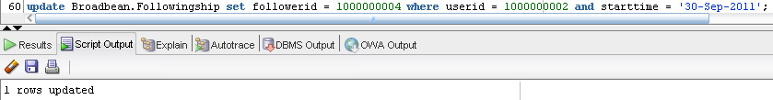

The FollowedByCount and FollowsCount for Boradbean.users table are automatically updated

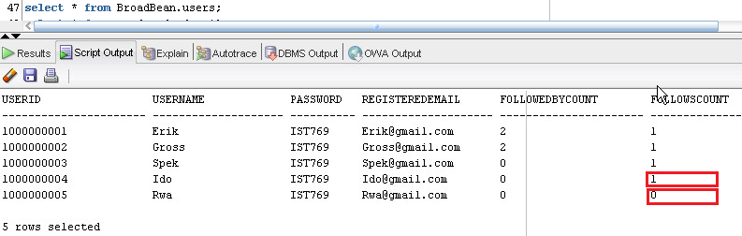

# 12. Packages

The purpose of creating the package below is to create a container for multiple program units and organize them. There are also other advantages we consider when we create the package: 1) The performance will be improved because when an object in a package is referenced for the first time, the entire package is loaded into memory which makes all other package objects immediately available for future calls to the package; 2) The format of package allows us to design the procedure and function interfaces first before we implement them; 3) Package allows for information hiding. We can easily make modification to the package if we want to make certain program units public or hide specific procedures and functions.

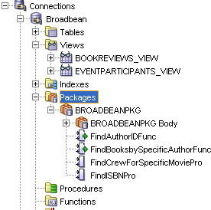

## a. Package Definition

create or replace

PACKAGE BroadbeanPkg AS

---Function Specifications---

--1.FindAuthorIDFunc: Find the author ID based on her/his first name and last name--

FUNCTION FindAuthorIDFunc

(

AuthorFnameIN IN Broadbean.Author.Fname%TYPE,

AuthorLnameIN IN Broadbean.Author.Lname%TYPE

)

RETURN INTEGER;

--2.FindBooksbySpecificAuthorFunc: Find all the books writen by a specific author--

FUNCTION FindBooksbySpecificAuthorFunc

(

AuthorFnameIN IN Broadbean.Author.Fname%TYPE,

AuthorLnameIN IN Broadbean.Author.Lname%TYPE

)

RETURN INTEGER;

---Procedure Specifications---

--1.FindISBNPro: Find a book's ISBN based on its name--

PROCEDURE FindISBNPro

(BookNameIN IN Broadbean.Book.BookName% TYPE, AuthorFnameIN IN Broadbean.Author.Fname%TYPE, AuthorLnameIN IN Broadbean.Author.Lname%TYPE, ISBNOUT OUT INTEGER);

--2.FindCrewForSpecificMoviePro: Find all the crew for a specific movie--

PROCEDURE FindCrewForSpecificMoviePro

(IMDBidIN IN Broadbean.Movie.IMDBid% TYPE);

END;

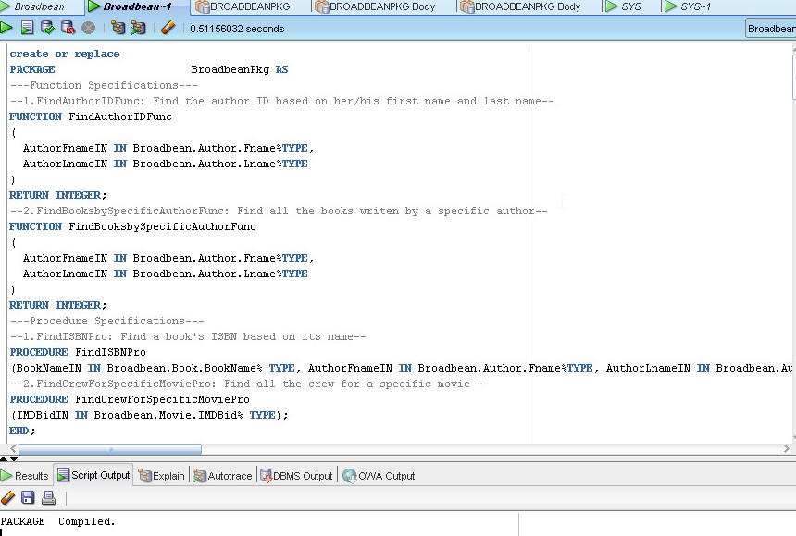

## b. Package Body

---Package Body---

create or replace PACKAGE BODY Broadbean.BroadbeanPkg AS

--Function Body--

--1.FindAuthorIDFunc Body--

FUNCTION FindAuthorIDFunc

(

AuthorFnameIN IN Broadbean.Author.Fname%TYPE,

AuthorLnameIN IN Broadbean.Author.Lname%TYPE

)

RETURN INTEGER

IS

AuthorIDCount INTEGER;

Multi_Author_EX EXCEPTION;

AuthorIDOUT Broadbean.Author.AuthorID%TYPE;

BEGIN

SELECT COUNT(*) into AuthorIDCount FROM Broadbean.Author where upper(trim(Broadbean.Author.Fname)) LIKE '%'||upper(trim(AuthorFnameIN))||'%' and upper(trim(Broadbean.Author.Lname)) LIKE '%'||upper(trim(AuthorLnameIN))||'%';

IF(AuthorIDCount>1)

THEN RAISE Multi_Author_EX;

END IF;

SELECT AuthorID into AuthorIDOUT FROM Broadbean.Author where upper(trim(Broadbean.Author.Fname)) LIKE '%'||upper(trim(AuthorFnameIN))||'%' and upper(trim(Broadbean.Author.Lname)) LIKE '%'||upper(trim(AuthorLnameIN))||'%';

return AuthorIDOUT;

EXCEPTION

When NO_DATA_FOUND

Then AuthorIDOUT := 0;

dbms_output.put_line('There is no author with the name '||AuthorFnameIN||' '||AuthorLnameIN);

RETURN AuthorIDOUT;

When Multi_Author_EX

Then

dbms_output.put_line('There are '||AuthorIDCount||' authors with the name '||AuthorFnameIN||' '||AuthorLnameIN);

AuthorIDOUT := AuthorIDCount;

RETURN AuthorIDOUT;

END FindAuthorIDFunc;

--2.FindBooksbySpecificAuthorFunc Body--

FUNCTION FindBooksbySpecificAuthorFunc

(

AuthorFnameIN IN Broadbean.Author.Fname%TYPE,

AuthorLnameIN IN Broadbean.Author.Lname%TYPE

)

RETURN INTEGER

IS

AuthorIDVAR Broadbean.Author.AuthorID%TYPE;

CURSOR BooksbySpecificAuthorCur IS

SELECT Broadbean.Book.ISBN, Broadbean.Book.BookName, Broadbean.Publisher.PublisherName, Broadbean.Language.LanguageName, Broadbean.Book.BookRating, Broadbean.Book.RatebyCount FROM Broadbean.Book JOIN Broadbean.BookAuthor ON Broadbean.Book.ISBN = Broadbean.BookAuthor.BookID JOIN Broadbean.Publisher on Broadbean.Book.PublisherID = Broadbean.Publisher.PublisherID join Broadbean.Language on Broadbean.Book.LanguageID = Broadbean.Language.LanguageID where Broadbean.BookAuthor.AuthorID = AuthorIDVAR;

BooksbySpecificAuthorRec BooksbySpecificAuthorCur%ROWTYPE;

BooksCount INTEGER;

BEGIN

AuthorIDVAR := FindAuthorIDFunc(AuthorFnameIN, AuthorLnameIN);

SELECT COUNT(*) into BooksCount FROM Broadbean.Book join Broadbean.BookAuthor on Broadbean.Book.ISBN = Broadbean.BookAuthor.BookID where Broadbean.BookAuthor.AuthorID = AuthorIDVAR;

OPEN BooksbySpecificAuthorCur;

LOOP

FETCH BooksbySpecificAuthorCur into BooksbySpecificAuthorRec;

EXIT WHEN BooksbySpecificAuthorCur%NOTFOUND;

dbms_output.put_line(BooksbySpecificAuthorRec.ISBN || ' ' || BooksbySpecificAuthorRec.BookName || ' ' || BooksbySpecificAuthorRec.PublisherName || ' ' || BooksbySpecificAuthorRec.LanguageName || ' ' || BooksbySpecificAuthorRec.BookRating || ' ' || BooksbySpecificAuthorRec.RatebyCount);

END LOOP;

CLOSE BooksbySpecificAuthorCur;

RETURN BooksCount;

EXCEPTION

When NO_DATA_FOUND

Then dbms_output.put_line('There is no author with the name '||AuthorFnameIN||' '||AuthorLnameIN);

RETURN BooksCount;

END FindBooksbySpecificAuthorFunc;

--Procedure Body--

--1.FindISBNPro Body--

PROCEDURE FindISBNPro

(BookNameIN IN Broadbean.Book.BookName% TYPE, AuthorFnameIN IN Broadbean.Author.Fname%TYPE, AuthorLnameIN IN Broadbean.Author.Lname%TYPE, ISBNOUT OUT INTEGER)

IS

AuthorIDVAR Broadbean.Author.AuthorID%TYPE;

ISBNCount INTEGER;

Multi_Book_EX EXCEPTION;

BEGIN

AuthorIDVAR := FindAuthorIDFunc(AuthorFnameIN, AuthorLnameIN);

SELECT COUNT(*) INTO ISBNCount from Broadbean.Book join Broadbean.BookAuthor on Broadbean.Book.ISBN = Broadbean.BookAuthor.BookID WHERE BookName LIKE '%'||upper(trim(BookNameIN))||'%' and AuthorID = AuthorIDVAR;

IF(ISBNCount > 1)

THEN RAISE Multi_Book_EX;

END IF;

SELECT ISBN INTO ISBNOUT from Broadbean.Book join Broadbean.BookAuthor on Broadbean.Book.ISBN = Broadbean.BookAuthor.BookID WHERE BookName LIKE '%'||upper(trim(BookNameIN))||'%' and AuthorID = AuthorIDVAR;

dbms_output.put_line('The ISBN is '||ISBNOUT);

EXCEPTION

WHEN NO_DATA_FOUND

THEN dbms_output.put_line('There is no book with the name '||BookNameIN||' and author id '||AuthorIDVAR);

WHEN Multi_Book_EX

THEN dbms_output.put_line('There is more than one book with the name '||BookNameIN||' and author id '||AuthorIDVAR);

END FindISBNPro;

--2.FindCrewForSpecificMoviePro Body--

PROCEDURE FindCrewForSpecificMoviePro

(IMDBidIN IN Broadbean.Movie.IMDBid% TYPE)

IS

CURSOR CrewForSpecificMovieCur IS

SELECT Broadbean.Movie.IMDBid, Broadbean.Movie.MovieName, Broadbean.Crew.CrewID, Broadbean.Crew.Fname, Broadbean.Crew.Lname, Broadbean.Crew.CrewBio, Broadbean.MovieCrew.CrewRole FROM Broadbean.Crew JOIN Broadbean.MovieCrew ON Broadbean.Crew.CrewID = Broadbean.MovieCrew.CrewID JOIN Broadbean.MOVIE on Broadbean.MovieCrew.MovieID = Broadbean.Movie.IMDBid where Broadbean.MovieCrew.MovieID = IMDBidIN;

CrewForSpecificMovieRec CrewForSpecificMovieCur%ROWTYPE;

BEGIN

OPEN CrewForSpecificMovieCur;

LOOP

FETCH CrewForSpecificMovieCur into CrewForSpecificMovieRec;

EXIT WHEN CrewForSpecificMovieCur%NOTFOUND;

dbms_output.put_line(CrewForSpecificMovieRec.IMDBid || ' ' || CrewForSpecificMovieRec.MovieName || ' ' || CrewForSpecificMovieRec.CrewID || ' ' || CrewForSpecificMovieRec.Fname || ' ' || CrewForSpecificMovieRec.Lname || ' ' || CrewForSpecificMovieRec.CrewBio || ' ' || CrewForSpecificMovieRec.CrewRole);

END LOOP;

CLOSE CrewForSpecificMovieCur;

END FindCrewForSpecificMoviePro;

END BroadbeanPkg;

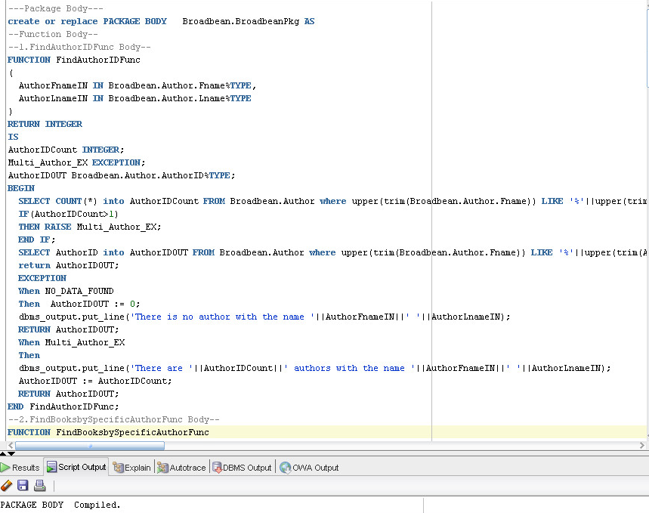

## c. Test Individual Procedures and Functions

### 1) BroadbeanPkg.FindAuthorIDFunc

--Test function FindAuthorIDFunc in the case when no match data exists--

begin

dbms_output.put_line(BroadbeanPkg.FindAuthorIDFunc('xx','yy'));

end;

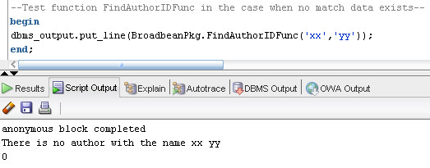

--Test function FindAuthorIDFunc in the case when one match record exists--

begin

dbms_output.put_line(BroadbeanPkg.FindAuthorIDFunc('Jo','Al'));

end;

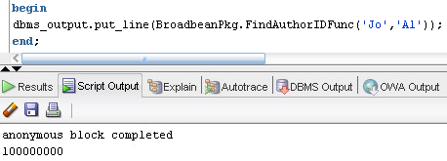

--Test function FindAuthorIDFunc in the case when more than one match record exist--

begin

dbms_output.put_line(BroadbeanPkg.FindAuthorIDFunc('a','m'));

end;

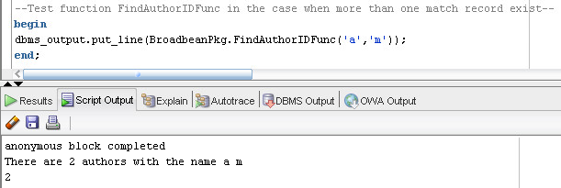

### 2) BroadbeanPkg. FindBooksbySpecificAuthorFunc

--Test function FindBooksbySpecificAuthorFunc when matched book data exists--

begin

dbms_output.put_line(BroadbeanPkg.FindBooksbySpecificAuthorFunc('John', 'Almon'));

end;

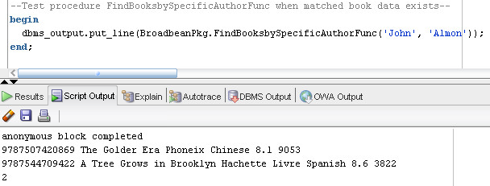

--Test procedure FindBooksbySpecificAuthorFunc when matched book data exists--

begin

dbms_output.put_line(BroadbeanPkg.FindBooksbySpecificAuthorFunc('John', 'Almon'));

end;

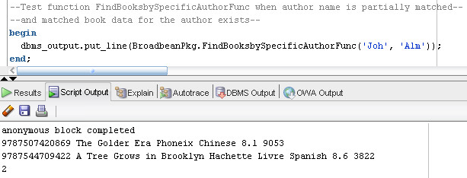

--Test function FindBooksbySpecificAuthorFunc when author exists--

--but no matched book data exists--

begin

dbms_output.put_line(BroadbeanPkg.FindBooksbySpecificAuthorFunc('Yan', 'Mo'));

end;

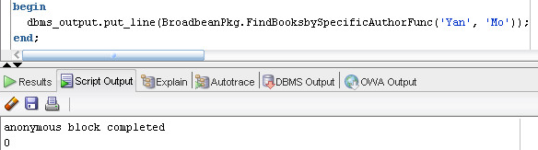

--Test function FindBooksbySpecificAuthorFunc when no matched author exists--

begin

dbms_output.put_line(BroadbeanPkg.FindBooksbySpecificAuthorFunc('Xiaobo', 'Wang'));

end;

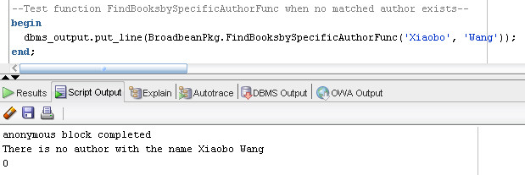

--Test function FindBooksbySpecificAuthorFunc when no matched author exists--

begin

dbms_output.put_line(BroadbeanPkg.FindBooksbySpecificAuthorFunc('Xiaobo', 'Wang'));

end;

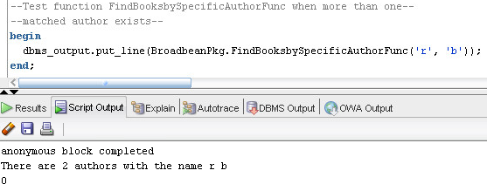

### 3) BroadbeanPkg. FindISBNPro

--Test procedure FindISBNPro when both book name and author name--

--are partially matched and matched book ISBN exist--

declare

ISBNOUT INTEGER;

begin

BroadbeanPkg.FindISBNPro('1q','Haru','Mura', ISBNOUT);

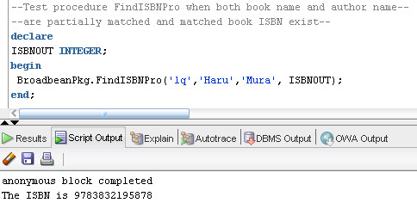

--Test procedure FindISBNPro when both book name and author name--

--are partially matched and matched book ISBN exist--

declare

ISBNOUT INTEGER;

begin

BroadbeanPkg.FindISBNPro('1q','Haru','Mura', ISBNOUT);

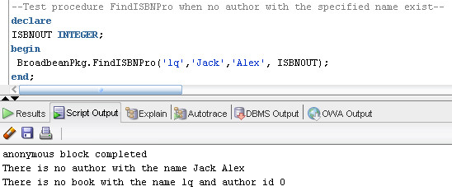

--Test procedure FindISBNPro when both book name and author name--

--are partially matched and matched book ISBN exist--

declare

ISBNOUT INTEGER;

begin

BroadbeanPkg.FindISBNPro('1q','Haru','Mura', ISBNOUT);

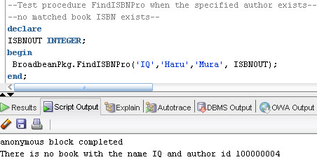

### 4) BroadbeanPkg. FindCrewForSpecificMoviePro

--Test procedure FindCrewForSpecificMoviePro when matched data exist--

begin

BroadbeanPkg.FindCrewForSpecificMoviePro(1065073);

end;

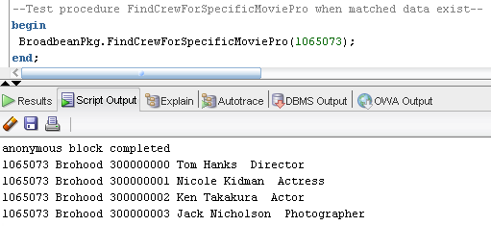

--Test procedure FindCrewForSpecificMoviePro when no matched data exists--

begin

BroadbeanPkg.FindCrewForSpecificMoviePro(1000000);

end;

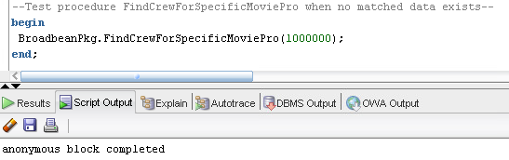

# 13. Forms

## a. Movie - Crew Form

The purpose of this form is to allow users to enter data for new movies in Movie table and allow them to enter each crew member’s information related to one specific movie in MovieCrew table. This is a master-detail form that allow the users to enter data into these two tables at the same time.

### Form Look

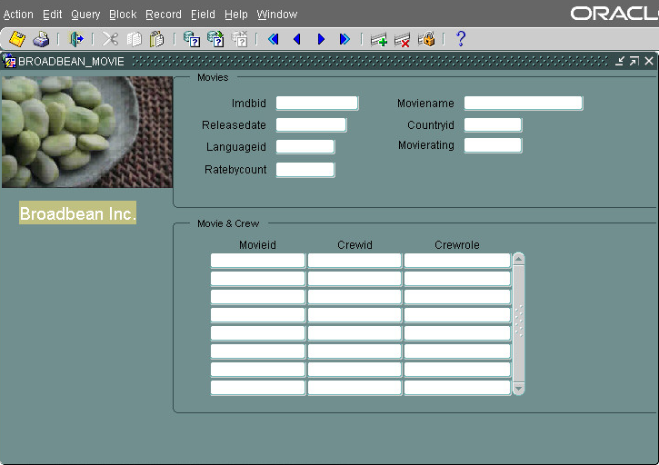

### Create Form

#### Create master form

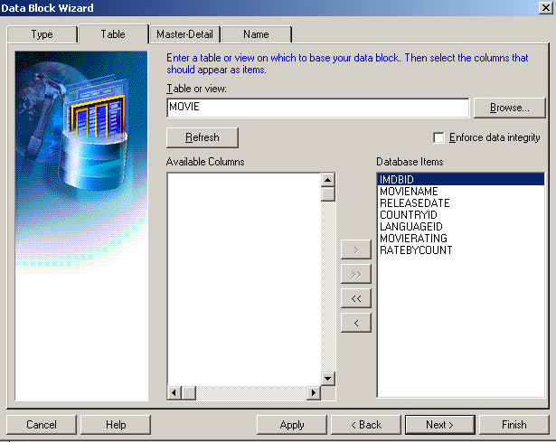

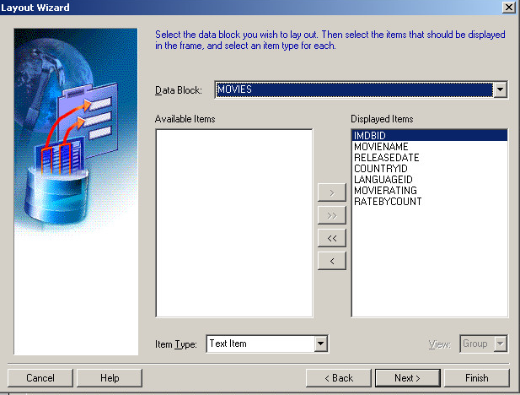

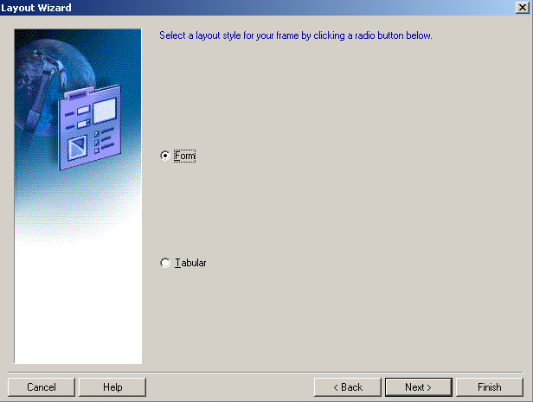

#### Create detail form

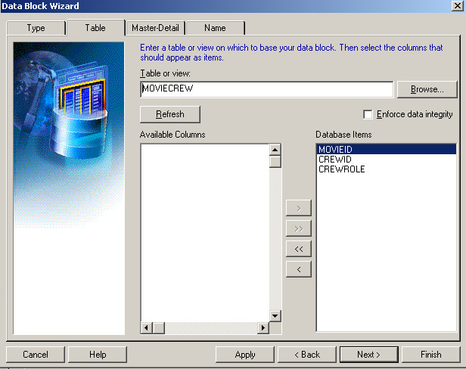

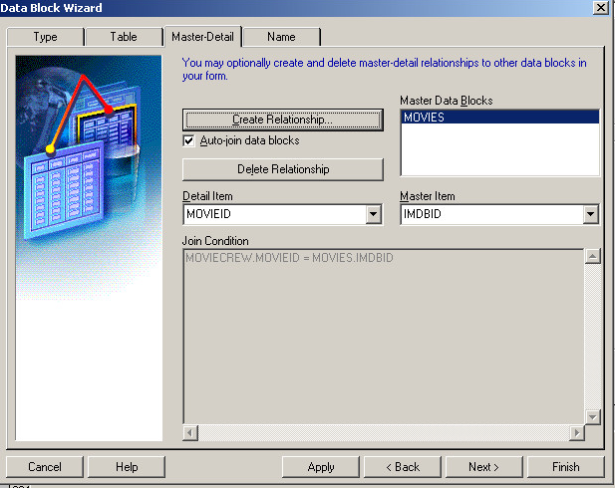

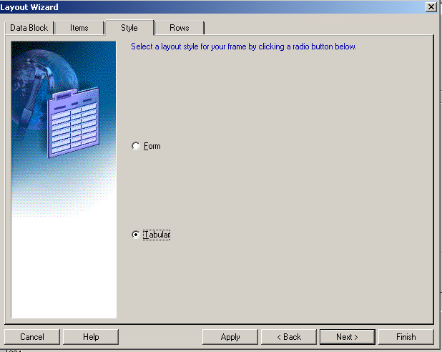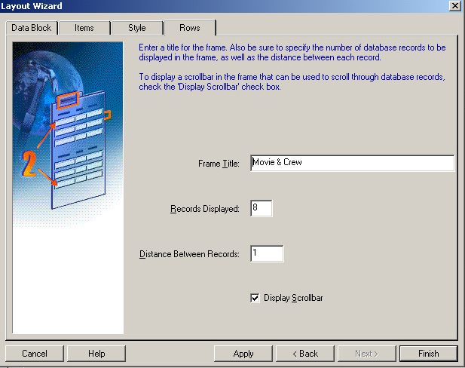  
Create LOV

#### Create Country Name LOV

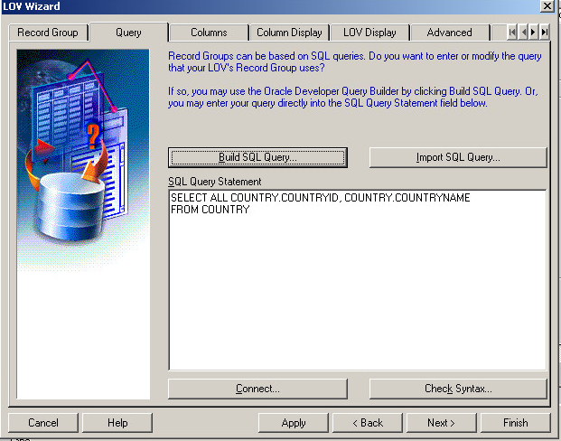

#### Create Language Name LOV

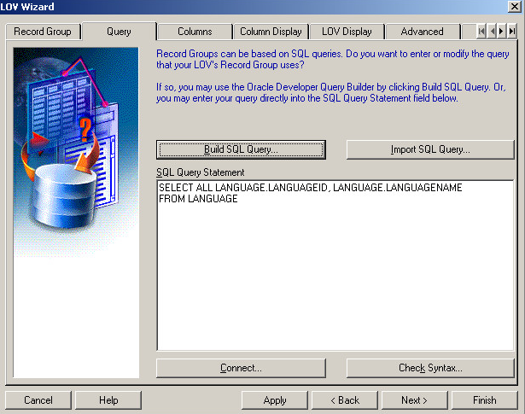

#### Create Crew Role LOV

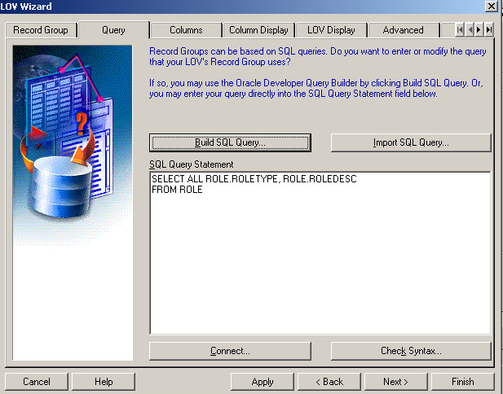

#### Create Crew ID LOV

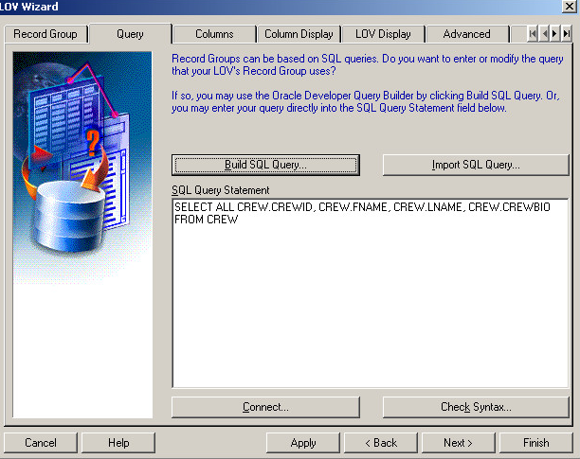

## b. Record – Performers Form

The purpose of this form is to allow users to enter data for new records in Record table and allow them to enter each performer’s information related to one specific record in RecordPerformer table. This is a master-detail form that allow the users to enter data into these two tables at the same time.

### Form Look

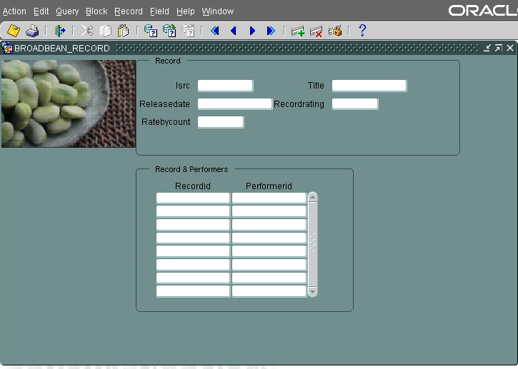

### Create form

#### Create master form

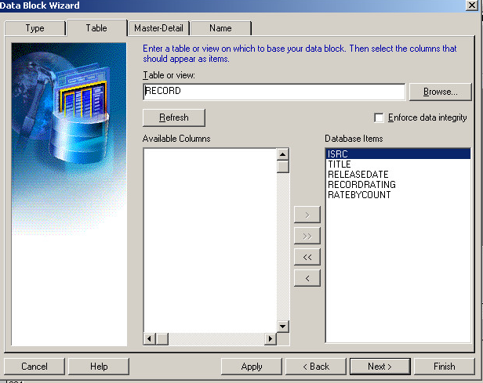

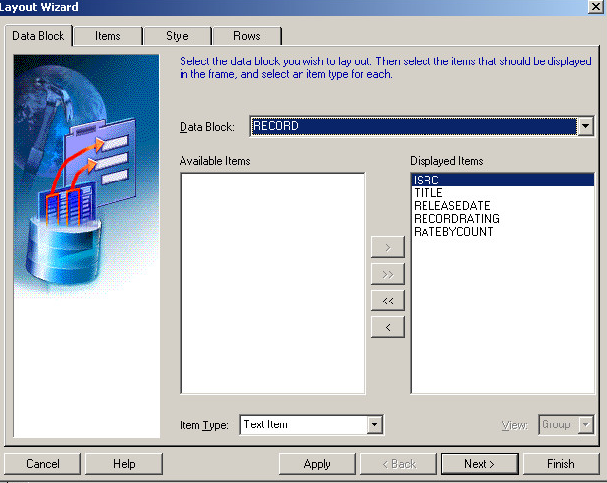

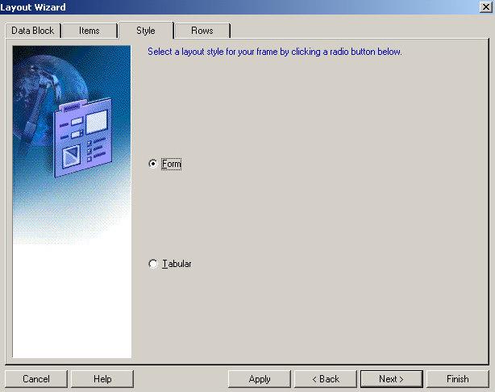

#### Create detail form

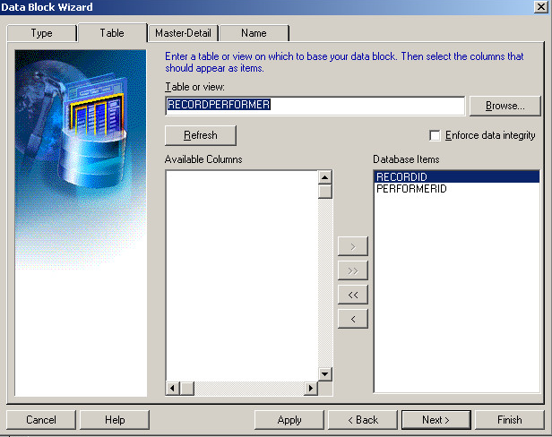

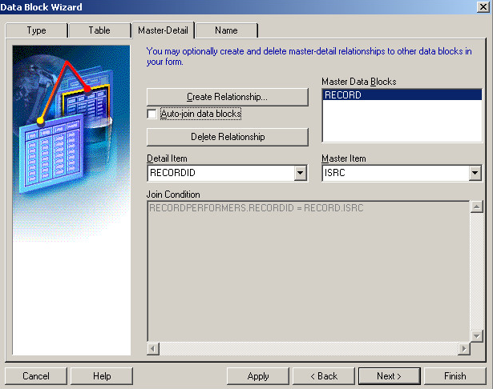

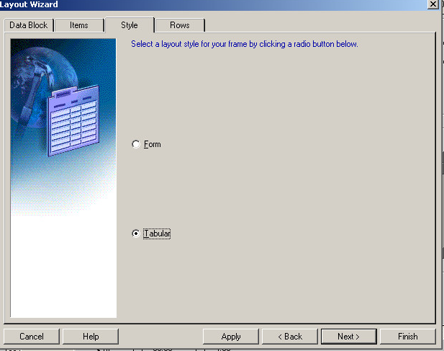

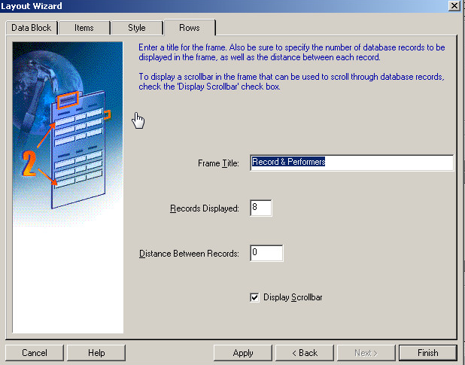

## c. Book - Reviews Form

### Form Look

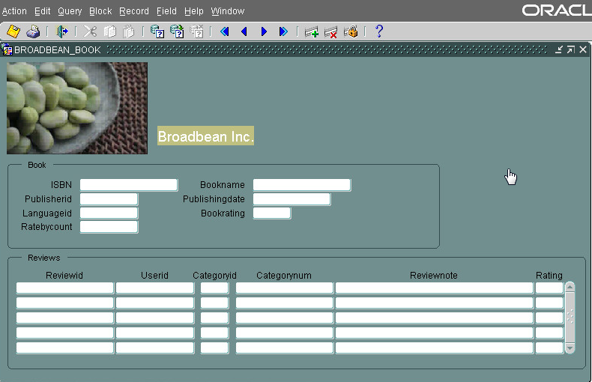

### Create form

#### Create master form

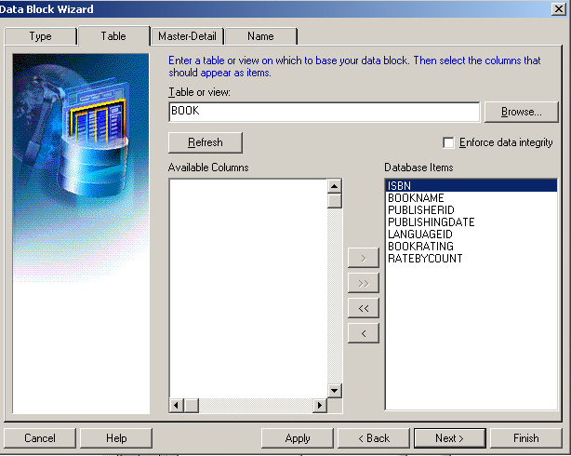

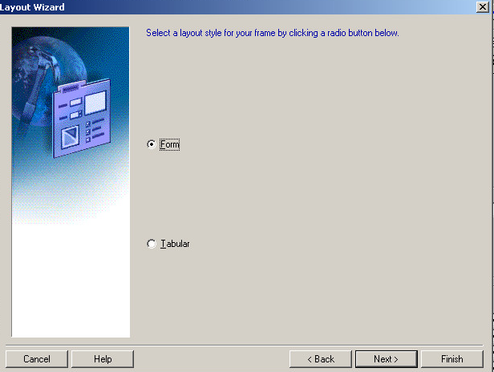

#### Create detail form

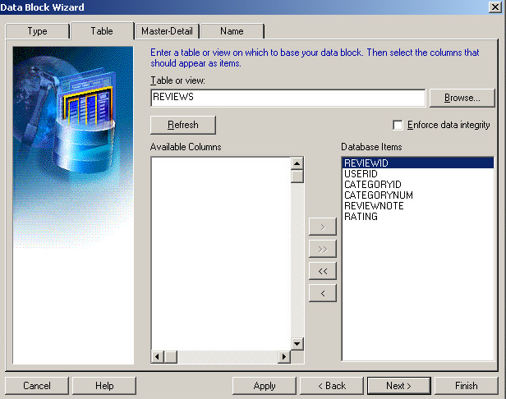

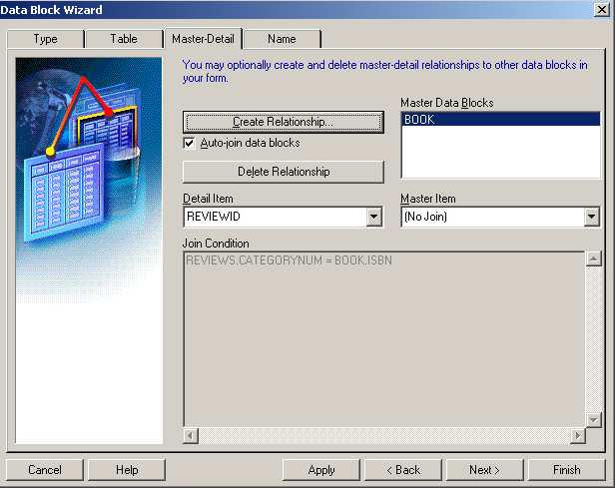



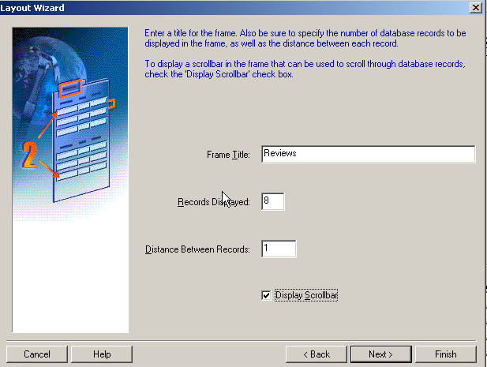

## d. How do the forms help with the “decisions not made.”

The form help visualize the data input, check the data format and ensure records in related tables are updated correctly. It makes it easier for DBA to enter records into the database and maintain the data records. This will help the database populated with the right data and thus facilitate the “decisions not made”. Correct data is the foundation for further tasks such as triggers, functions, procedures, etc. and quicken the process of decision-making.

## 14. Data

## a. Movie - Crew Form

### Input data

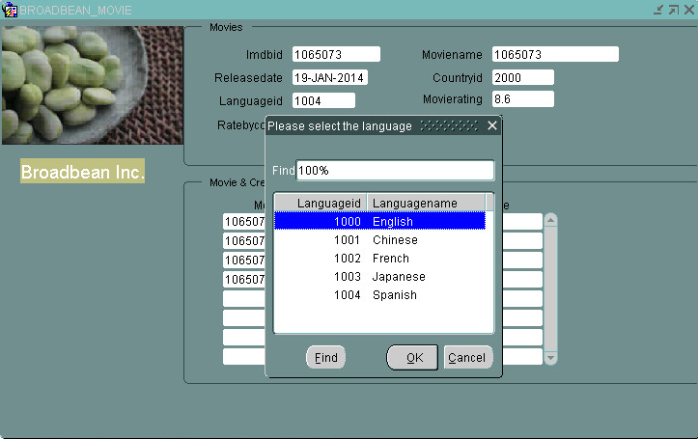

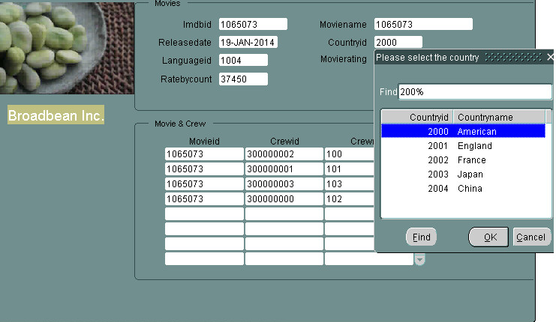

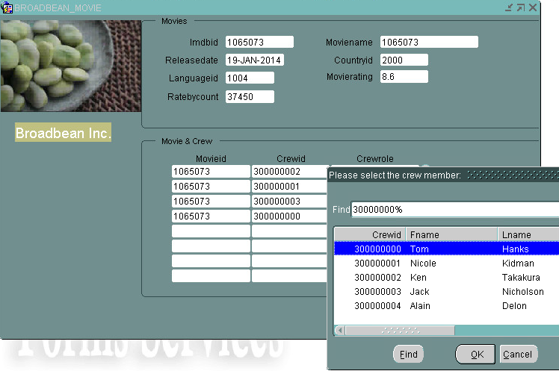

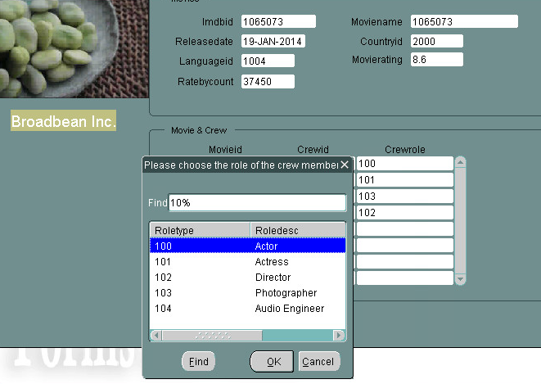

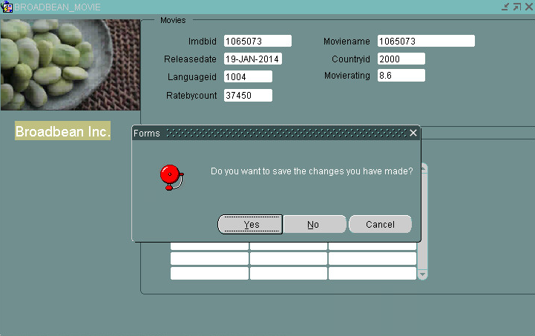

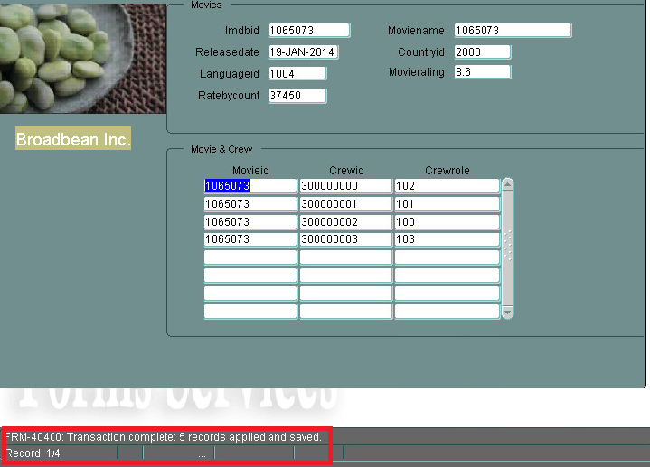

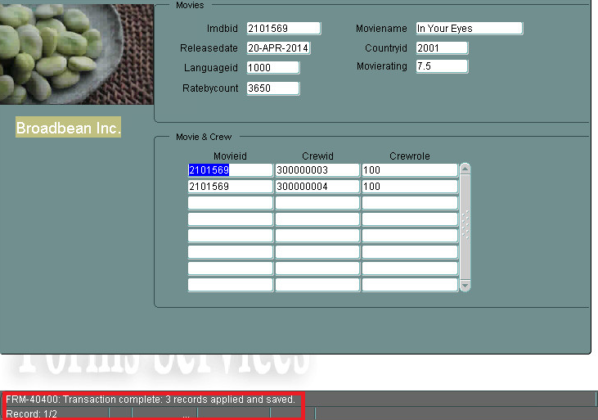

### Test input

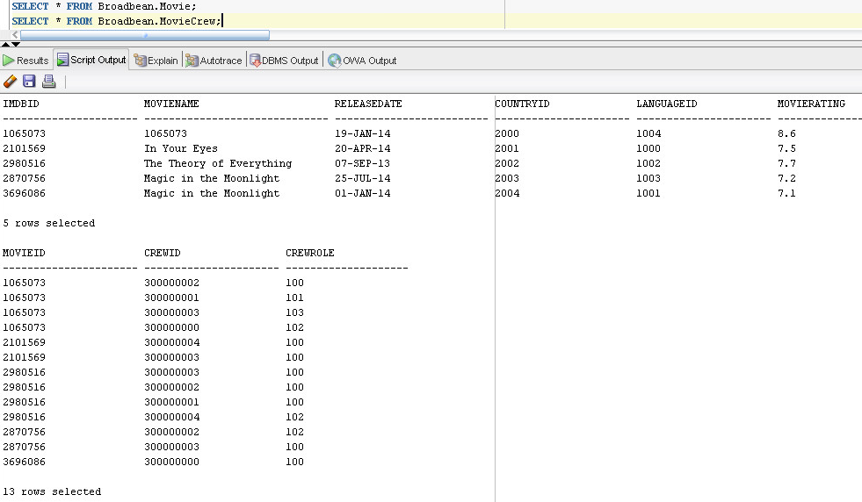

(PS: due to errors I made unintentionally when inserting data to Role table, I changed the Crewrole in MovieCrew table to the data below by using the input form:

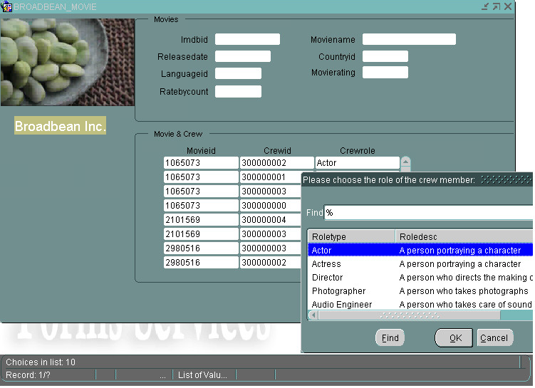

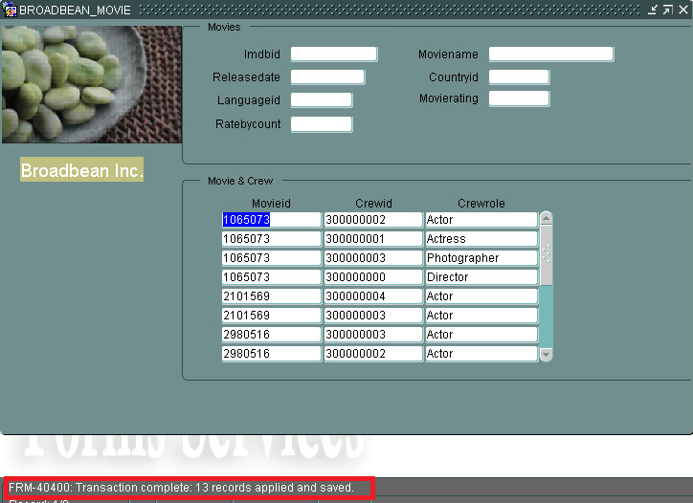

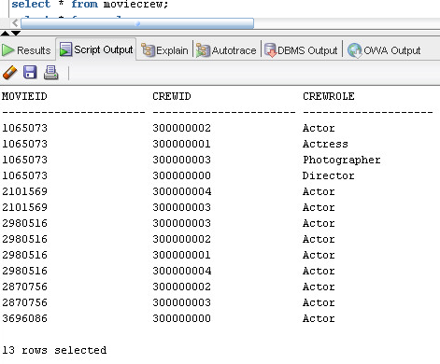)

## b. Record – Performer Form

### Input data

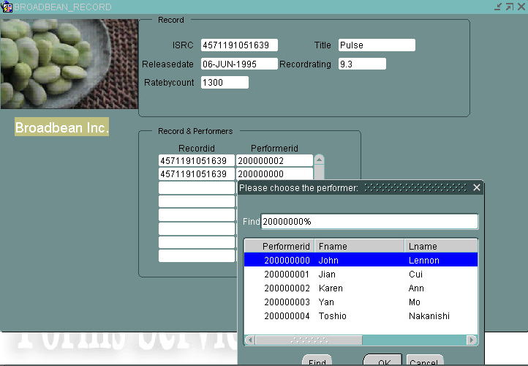

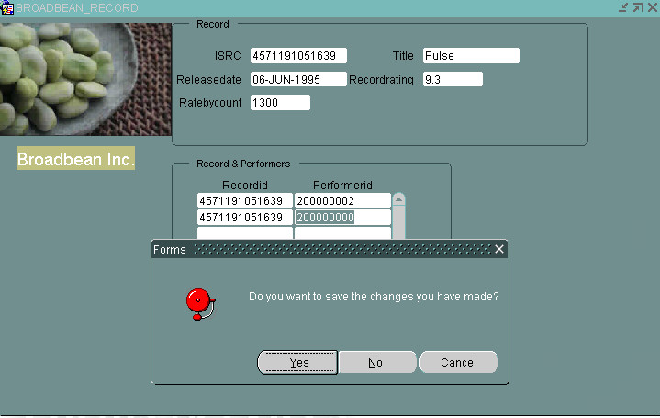

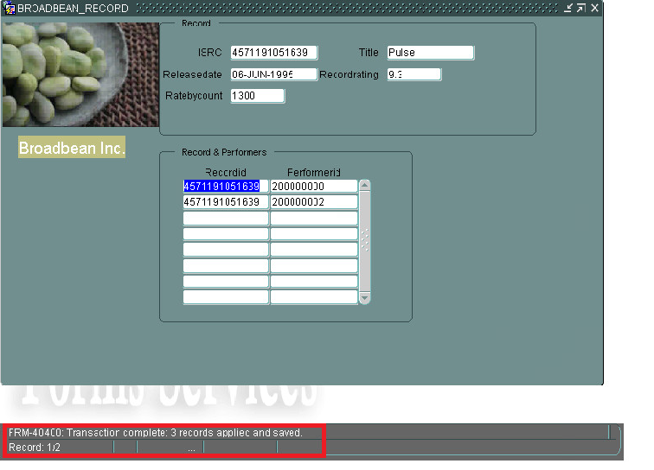

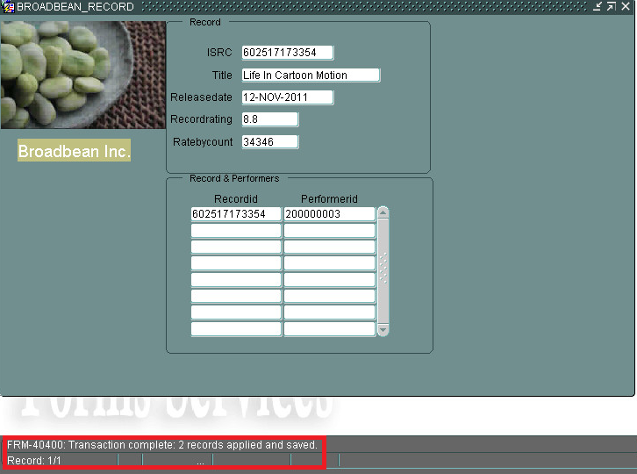

### Test input

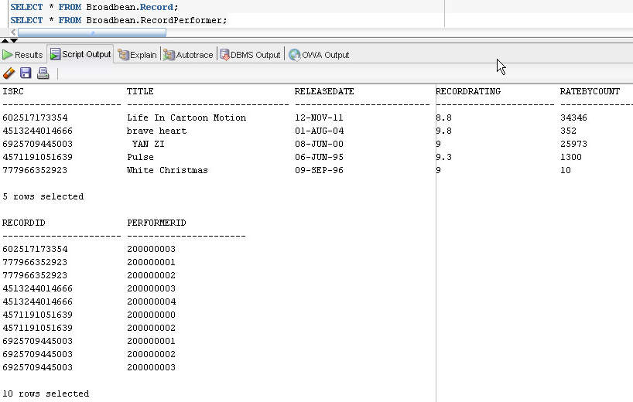

## c. Book - Review Form

### Input data

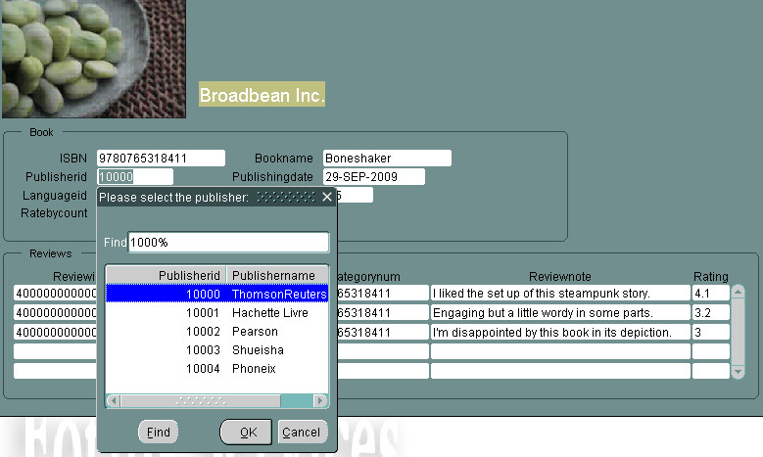

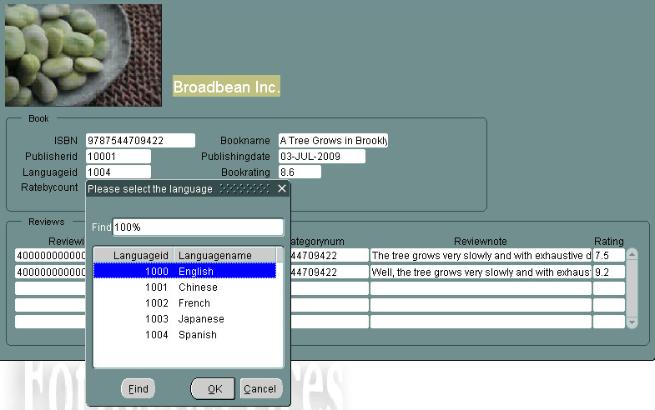

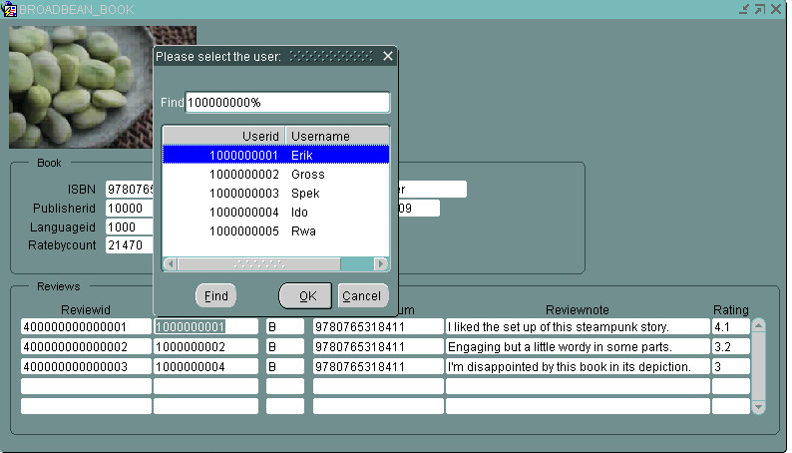

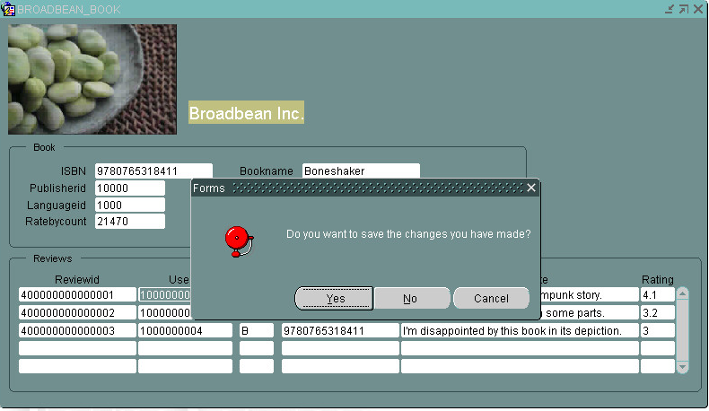

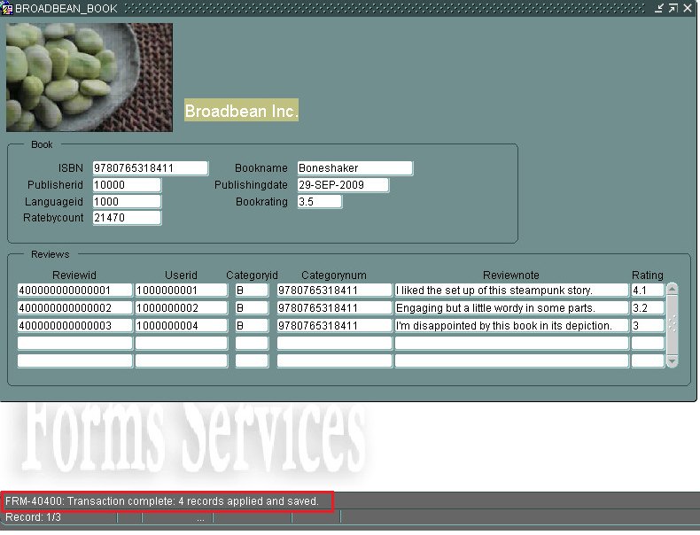

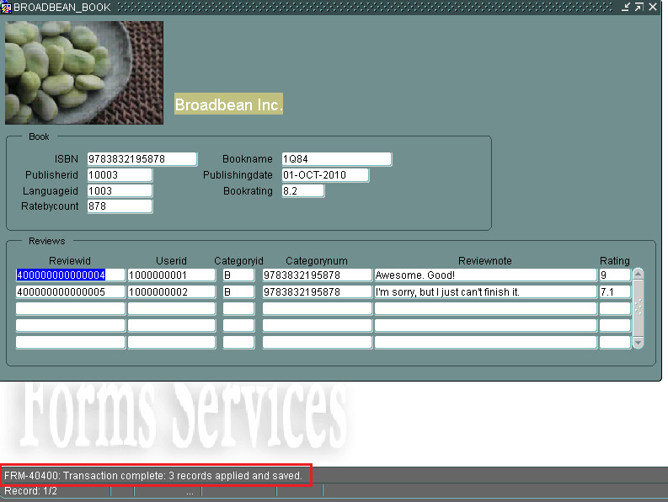

### Test input

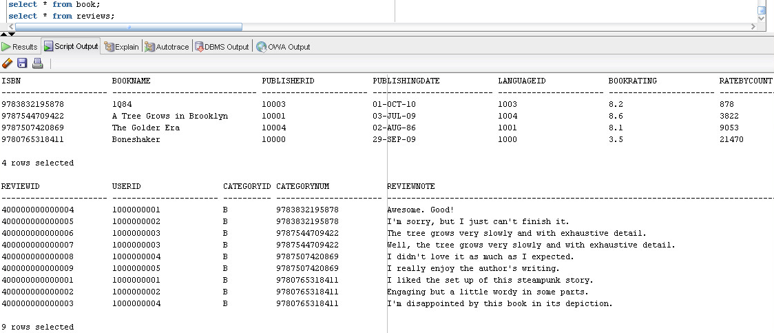

After the book’s data are input, we also insert several records into the BookAuthor table:

insert into bookauthor values(9783832195878, 100000004);

insert into bookauthor values(9787544709422, 100000000);

insert into bookauthor values(9787507420869, 100000000);

insert into bookauthor values(9780765318411, 100000002);

insert into bookauthor values(9783832195878, 100000001);

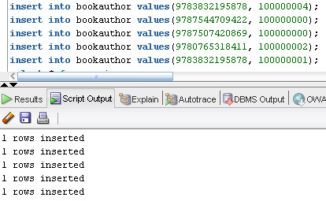

This happens before we create packages, functions and procedures.

# 15. Reports

## a. Event & Participants Report

The purpose of the report to display event information as well as all the participants for each event. The report allow users to browse what evens are available and who are participating in these events now.

### Create report

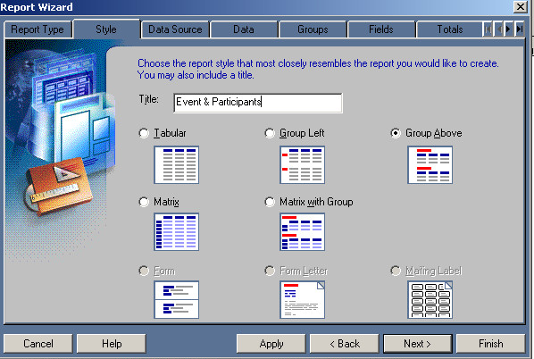

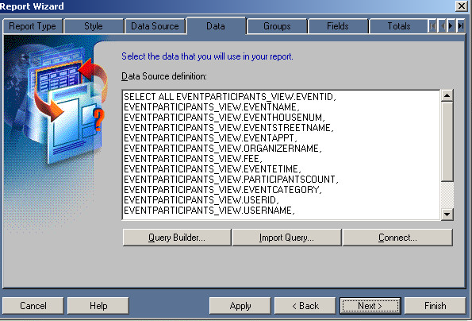

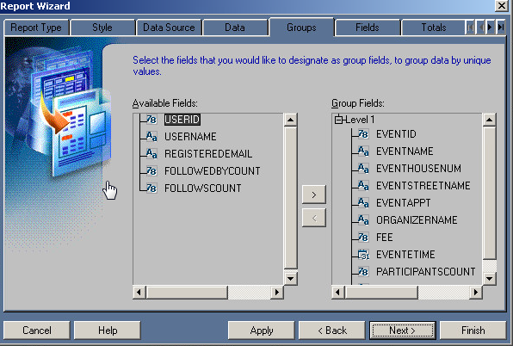

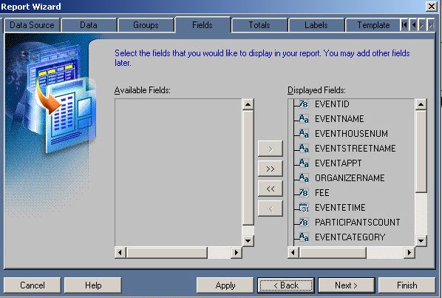

### Paper layout

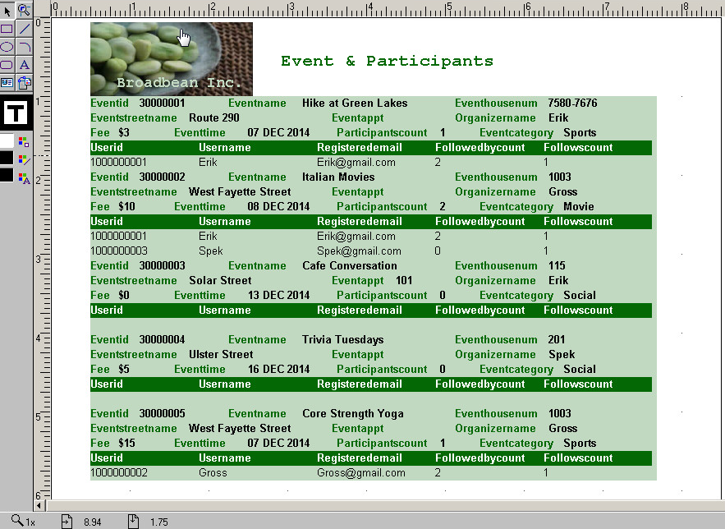

Web layout

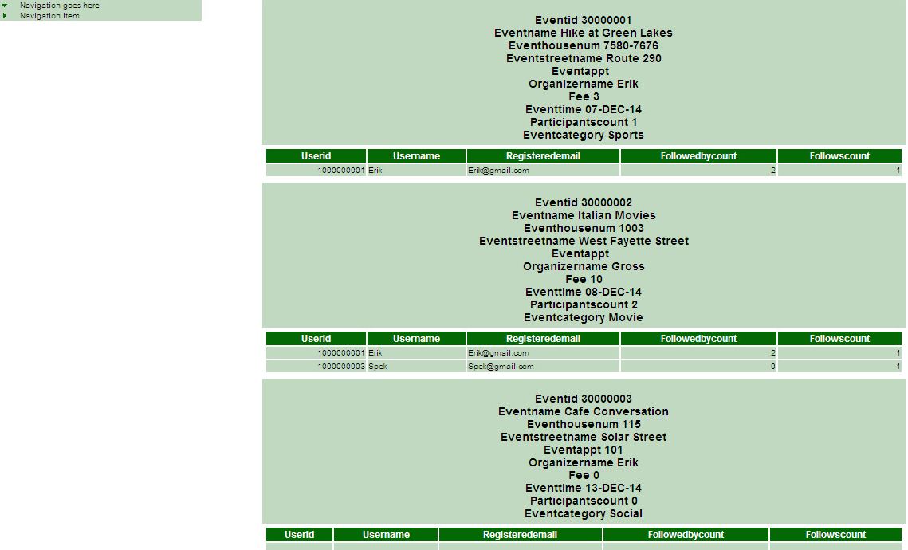

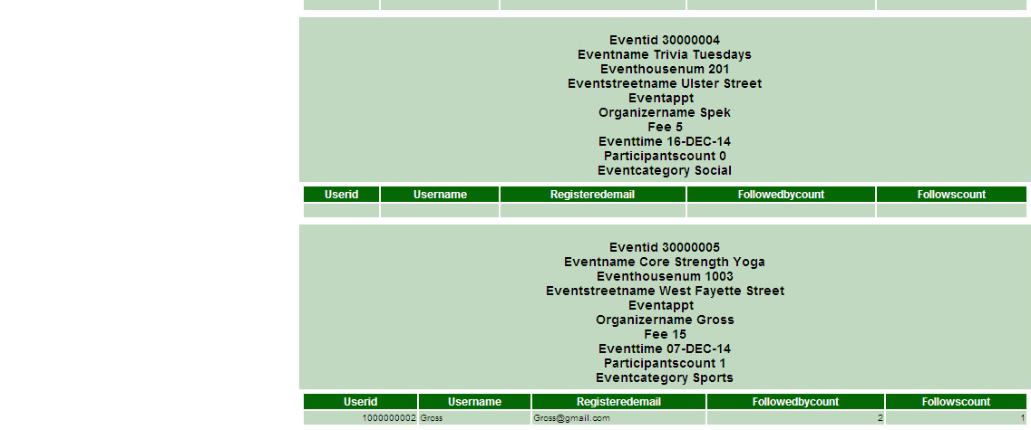

## b. Book & Reviews Report

The purpose of the report to display book information as well as all the reviews for each book. The report allow users to browse all the books and all the reviews for each book.

### Create report

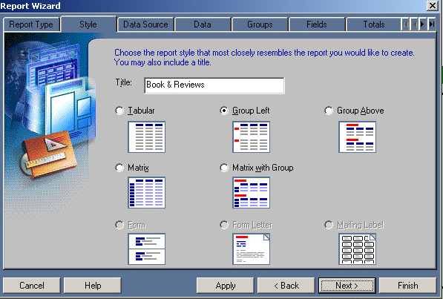

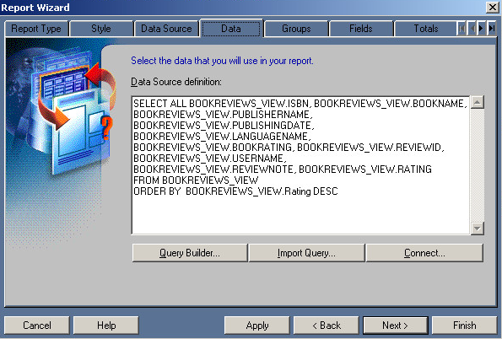

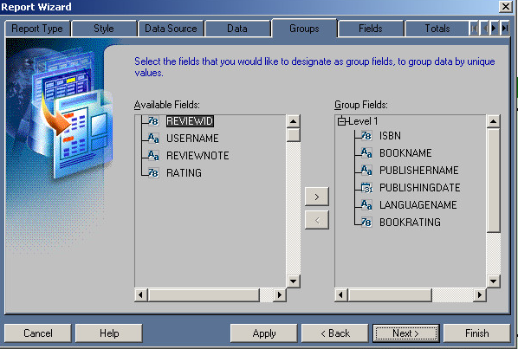

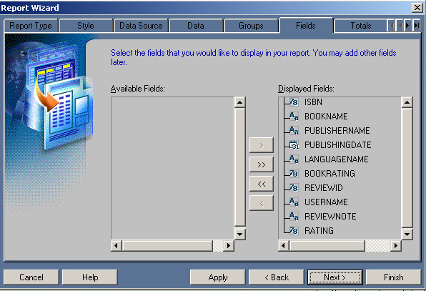

### Paper layout

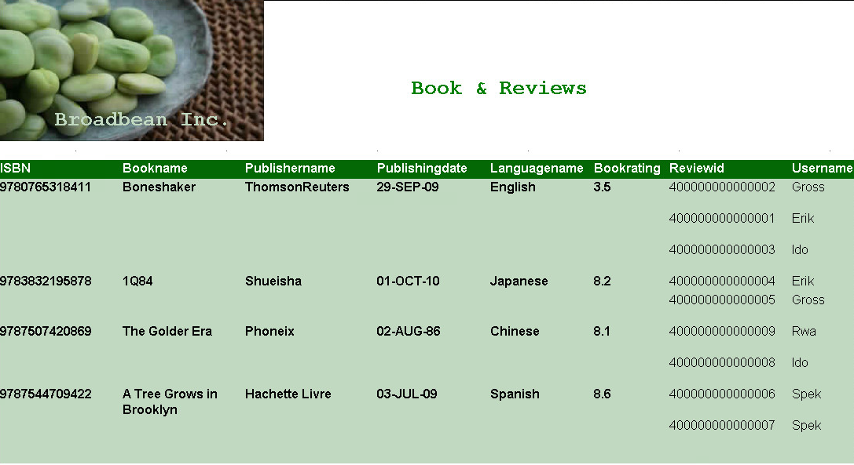

Right-hand side:

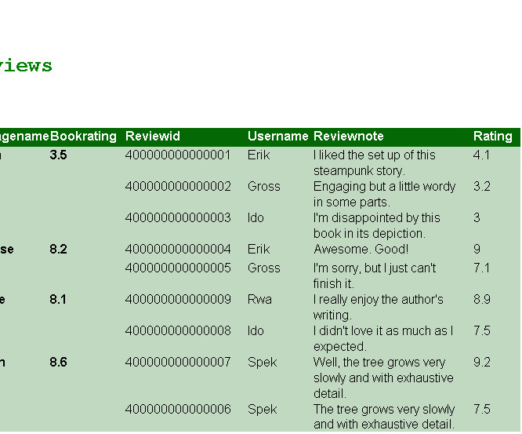

### Web layout

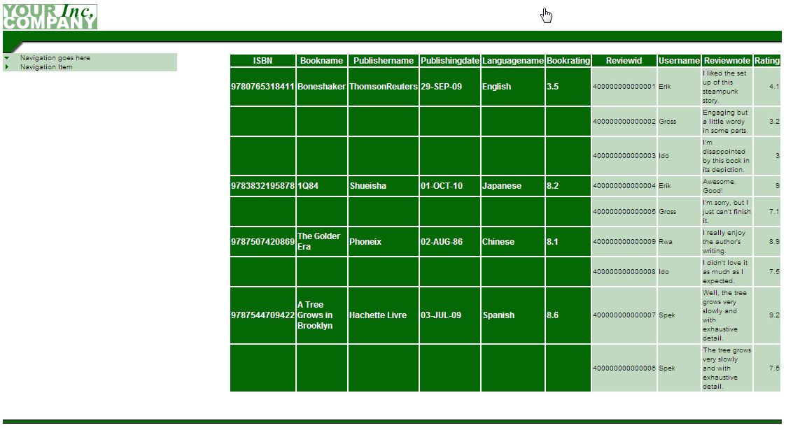

## c. Report with parameters

We added parameters to the Book & Review report:

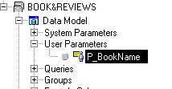

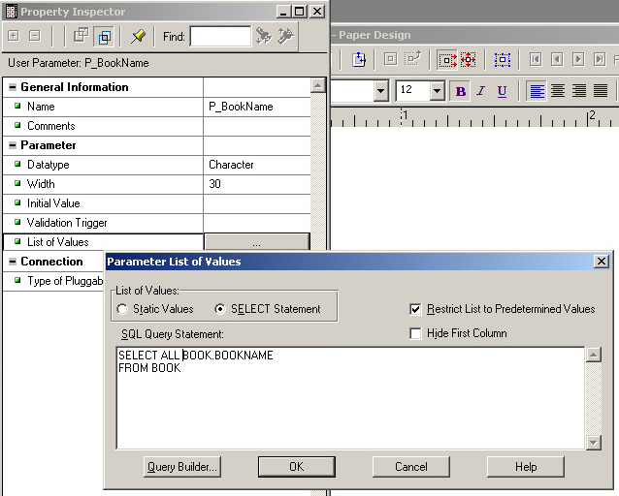

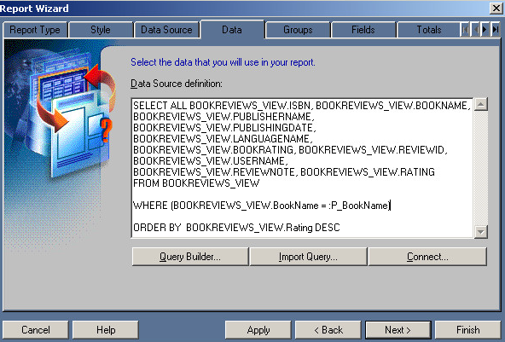

This time when we run the report, we need to select the parameter first:

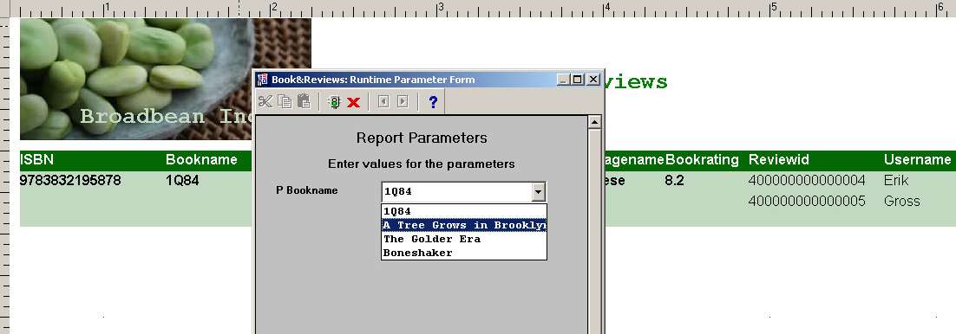

And the result is displayed as follows:

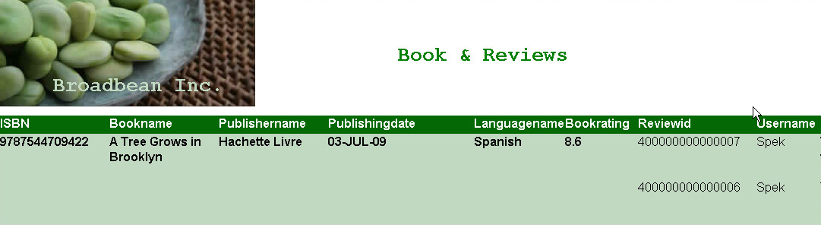

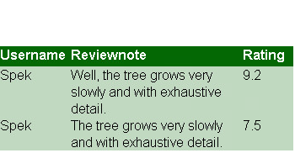

The same when we run the web layout:

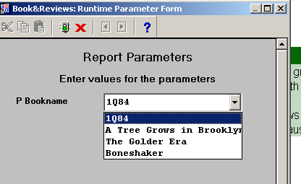

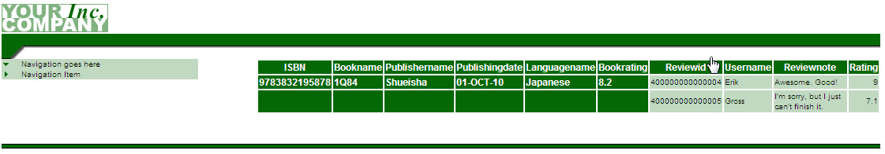

## d. How do these reports help answer the decisions that could not be made?

The Event & Participants Report visually display what events attract the most participation and who are participating these events in different distinctive sections and colors.

The Book & Review Report visually display what books are rate the highest and what are the specific reviews for each book in different distinctive sections and colors.

Thus we can make relevant decisions accordingly by looking at the report output.

# 16. Backup/Recovery

## a. Why choose specific methodology?

For Broadbean Inc. their users of the Music, Movie & Record Reviews Sharing System include both internal users and external visitors. Internal users are employees who are responsible for the database maintenance. Static data, such as data in tables like Movie, Record, Book, Performers, etc. will be input and updated by these staff. External visitors are the website’s clients. They will post reviews, participate in events and follow each other in the website. Both types of users will interact with the database.

A cold backup is possible when the employees cease their work and the website terminates external visiting for a short time by posting an announcement on the website.

A hot backup might be necessary in certain cases when the website is in rush hours and the database needs to be backed up for other related website maintenance procedures.

b. Cold backup procedure  
1) Use schema with System DBA privilege to shut down the database

After entering SQL*PLUS with the schema, enter the following command:

SHUTDOWN immediate

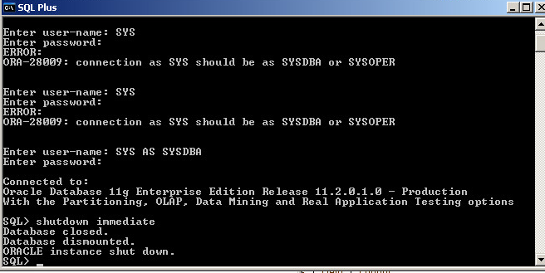

2) Copy the required database files into a backup folder

Like shown in the image below, we’ll copy the red underlined files into a new folder.

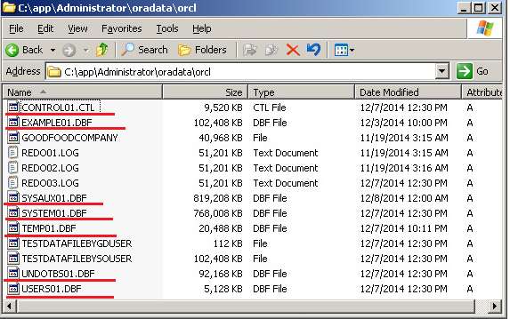

3) Start up the database

Type the following command in SQL*PLUS:

STARTUP PFILE=c:\app\Admnistrator\admin\orcl\pfile\init.ora.832014163710

The name of PFILE depends on the most recent parameter file you have.

## c. Hot backup procedure

1) Place the database in ARCHIVELOG mode

Check the current Database Log Mode by typing the following command in SQL*PLUS;

archive log list

If the Database Log Mode is “No Archive Mode”, change it to “Archive Mode” by type the following command:

Archive Mode

2) Backup the parameter file, control files and data files by any valid copy procedure

3) Archive the redo log files

4) Backup the archive

## d. Recover using a cold backup

1) Shut down the database

2) Restore the control file and data files

3) Restart the database

We also need to make sure that all the files were backed up at the same time, or else problems may result.

## f. recover using a hot backup

1) Shut down the database

2) Restore to the latest hot backup

3) Restart the database with restrictions session privileges

4) Recover the changes from the archive files

5) Restart the database

To help manage the backup/recovery process, we can use a utility provided by Oracle called RMAN (Recovery Manager). This is a command line utility and can be very useful.

# 17. Performance/Tuning

The monitoring tools in Oracle Enterprise Manager (EM) and SQL queries using the V$ performance views can be used by DBA to determine what resources need to be adjusted to get the desired database performance.

## a. Monitoring performance

### 1) Performance Monitoring using Enterprise Manager

We can access the performance monitoring tools by selecting the Performance tab in Enterprise Manager:

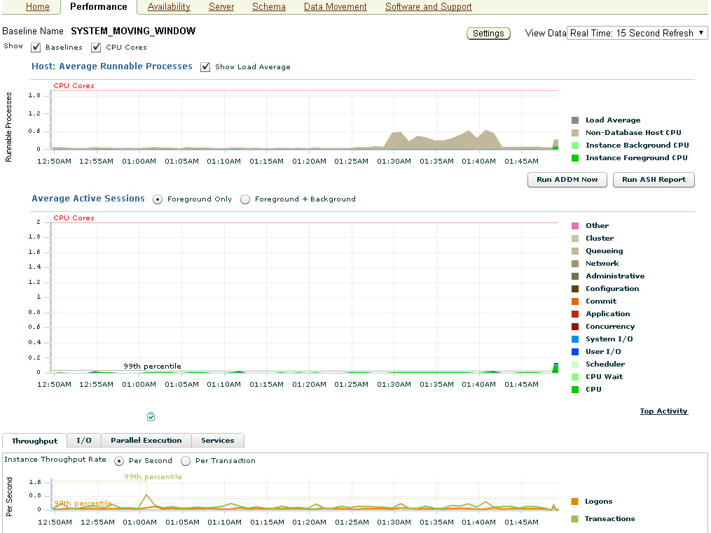

Here we can monitor the consumption of the three major resource components: CPU time, Memory usage and Disk I/O by using a variety of tools such as: Database Locks, Performance Manager, Performance Overview, Top Session, Top SQL and Instance Activity.

#### Performance Manager

If we choose System I/O in the image above, then the following Performance Manager window will open up:

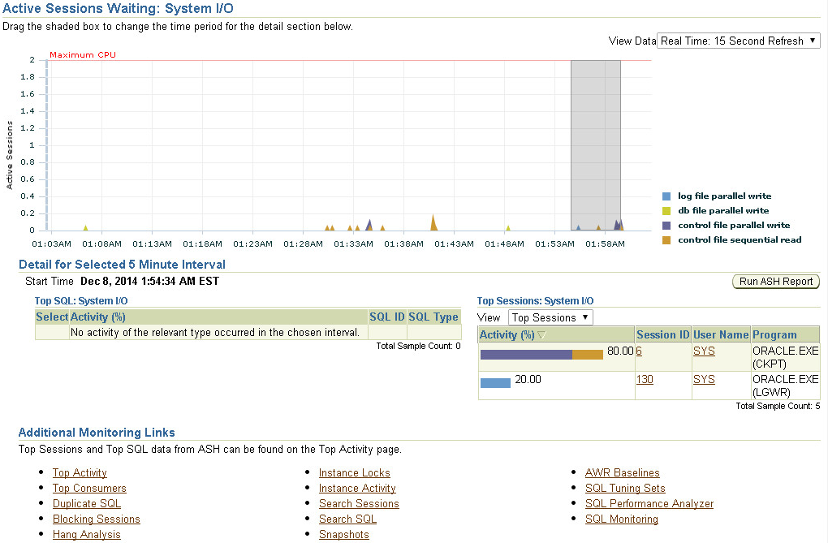

#### Top Activity

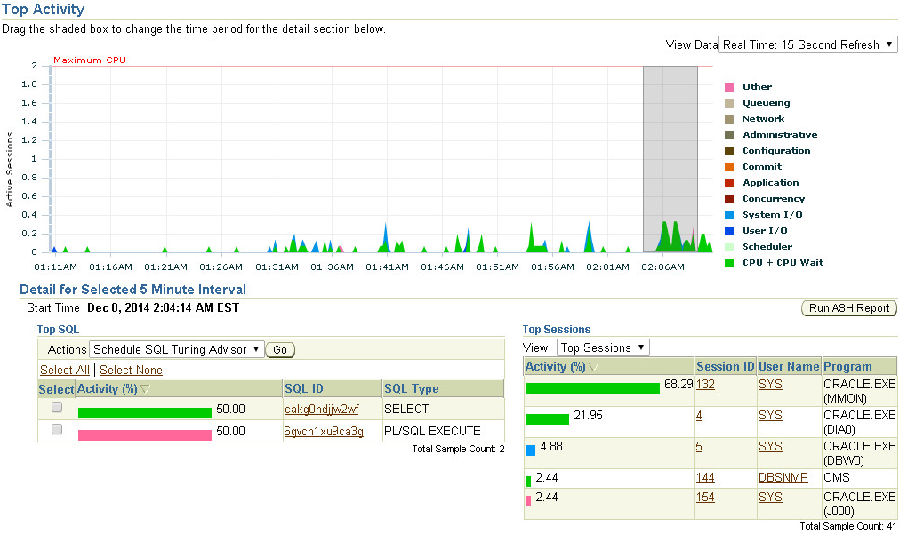

The Top Activity allows us to monitor Top Sessions and Top SQL. Here the DBA can determine which process or user is consuming the majority of the system resources so that s/he can take corrective that may include terminating a user session.

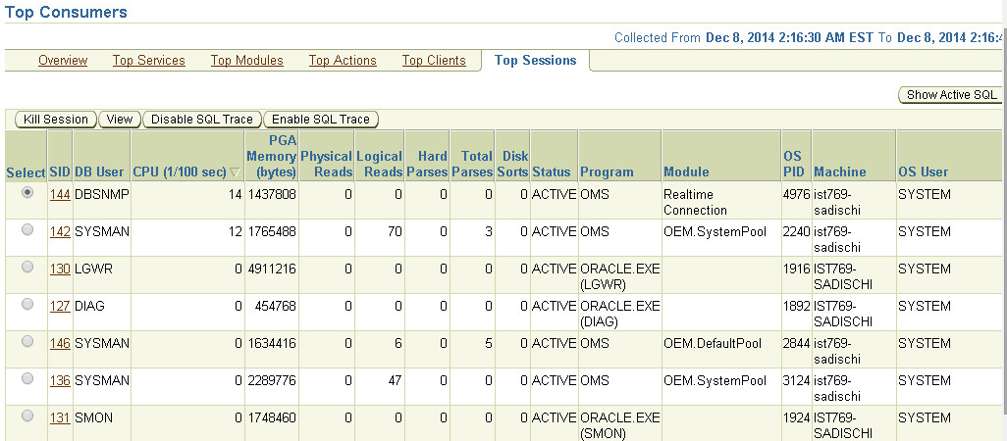

#### Top SQL

The Top SQL is a tool for monitoring the actual SQL commands and their effect on overall system performance. To achieve high performance, Oracle buffers the most commonly used SQL commands in the SGA’s Shared Pool and the most commonly used data blocks in the SGA’s Database Buffer Cache.

#### Top Consumers

Top Consumer tool displays which resources are being consumed.

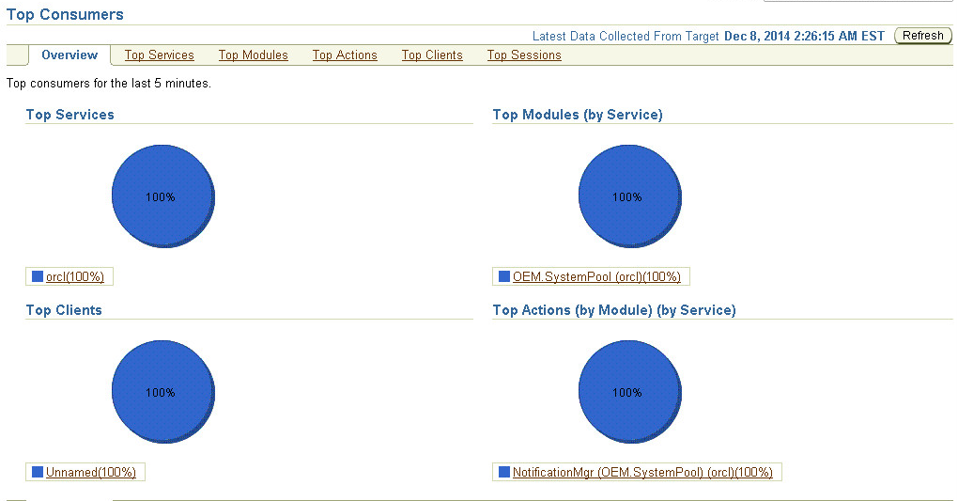

### 2) Using SQL to Monitor Performance

There were times when we might want to create special performance reports that are no part of EM. Oracle has provided a number of performance Views prefixed with V$ that allow us (DBA) to access the performance statistics that captured by Oracle.

A couple of commonly used views are as follow if we query using the SQL*PLUS:

SQL> desc vs$datafile

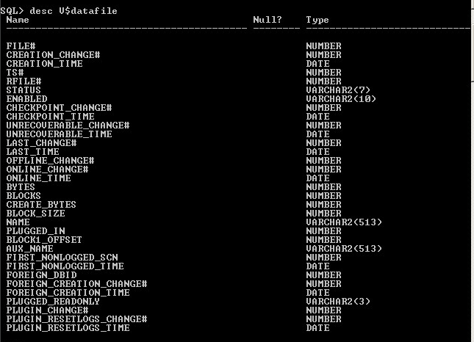

SQL> Select name, status, bytes, blocks from v$datafile;

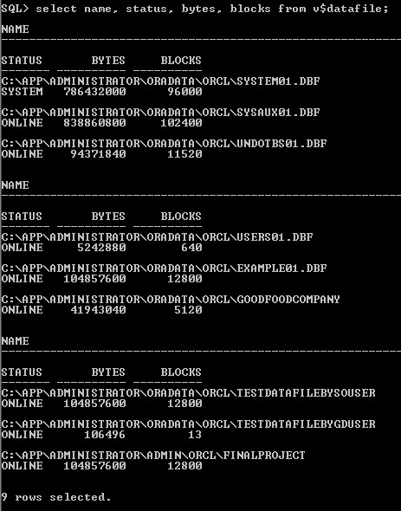  
SQL> desc v$filestat;

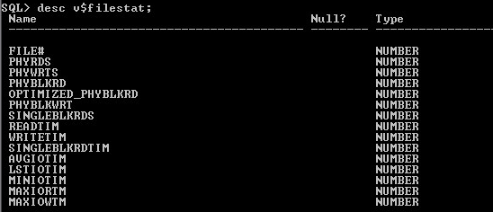

SQL> select * from v$filestat;

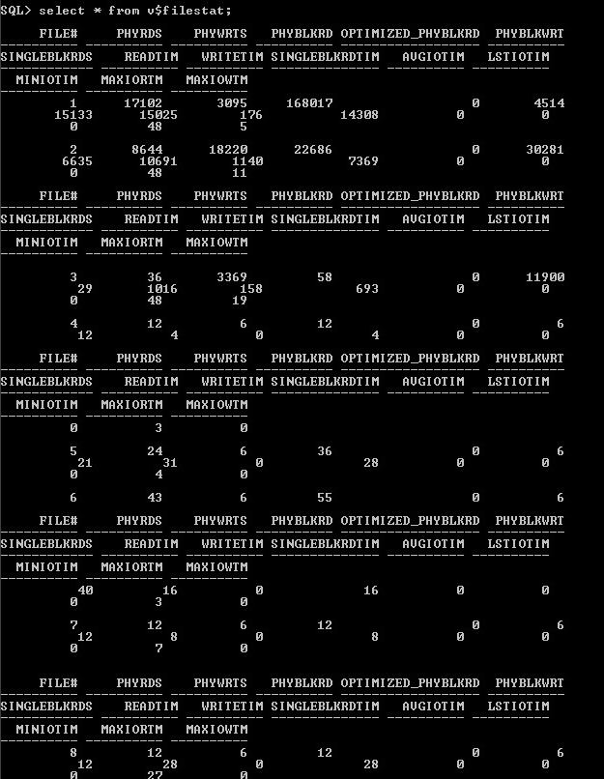

## b. Performance tuning

### 1) Tune Database Buffer Cache

We can modify the SGA buffers and pools by editing the parameter file (init.ora) using a tool like Notepad or by using EM.

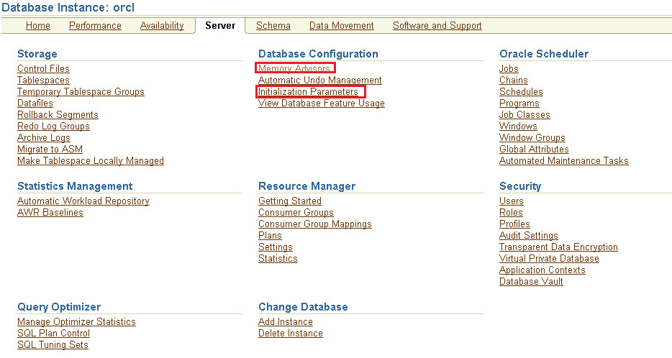

### 2) Tune by Advisor Central

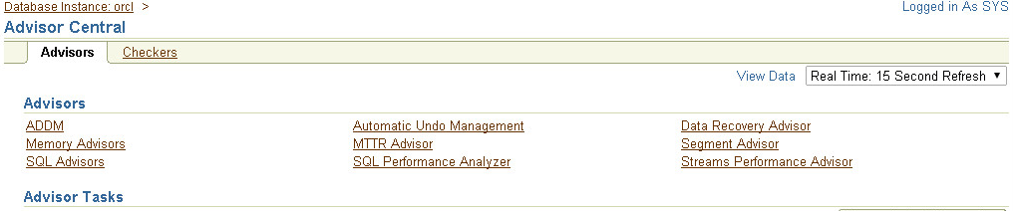

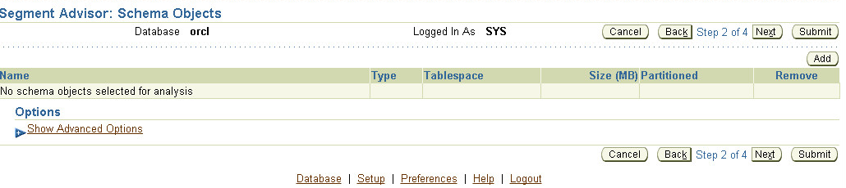

If there are any space problems the segment advisor report offers suggestions on a recommended course of action to improve performance.

### 3) Tune by SQL

#### Test the SGA Shared Pool and the Database Buffer Cache

I used the script below to track the performance:

select * from moviecrew where movieid = 1065073;

SELECT SUBSTR(USER,1,10) AS Student,

SUBSTR(SQL_TEXT,24,30) AS SQL,

Executions AS Times_Run,

Fetches,

Disk_Reads,

buffer_Gets,

Rows_Processed AS Rows_Read,

CPU_TIME AS CPU,

LAST_LOAD_TIME AS Run_Time

FROM V$SQL

WHERE

SUBSTR(SQL_TEXT,31,14) = 'MovidID ='

AND LAST_LOAD_TIME IS NOT NULL

ORDER BY LAST_LOAD_TIME DESC;

ALTER SYSTEM FLUSH BUFFER_CACHE;

ALTER SYSTEM FLUSH SHARED_POOL;

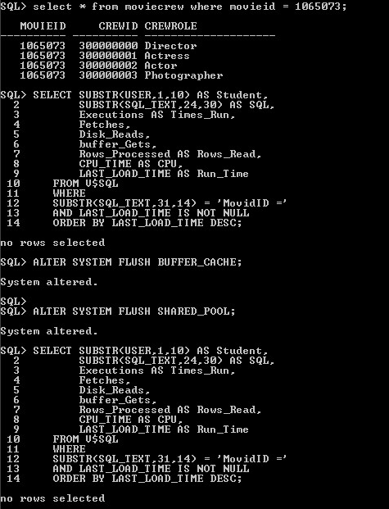

But no rows are selected, the reason could be currently we have too few data records. However, as what we did in our lab showed, big large amount of data, allowing SGA Shared Pool and the Database Buffer Cache to hold data that is commonly or frequently used could be instrumental to minimizes the costly and slow I/O accesses to the disk, and thus improve performance.

#### Create an Execution or Explain Plan

We execute the following script:

SET AUTOTRACE ON;

EXPLAIN PLAN FOR

select m.imdbid, m.moviename, m.releasedate, mc.crewid from movie m join moviecrew mc on m.imdbid = mc.movieid;

SELECT * FROM table(DBMS_XPLAN.DISPLAY);

And we got the result below:

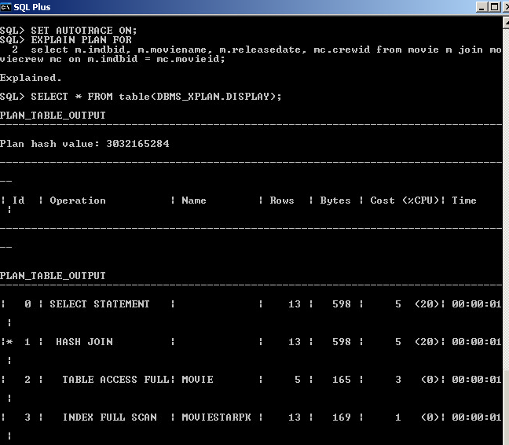

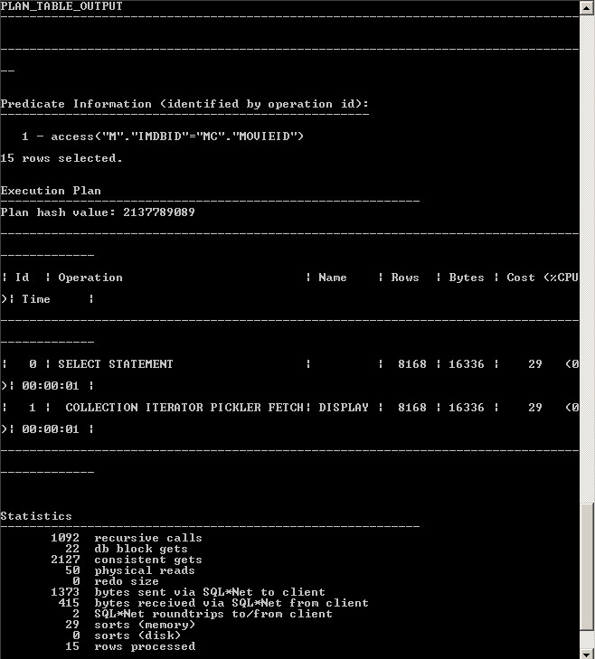  
Then we create index on MovieCrew table’s MovieID attribute and rerun the plan:

CREATE INDEX MovieIDInx ON MovieCrew(MovieID);

EXPLAIN PLAN FOR

select m.imdbid, m.moviename, m.releasedate, mc.crewid from movie m join moviecrew mc on m.imdbid = mc.movieid;

SELECT * FROM table(DBMS_XPLAN.DISPLAY);

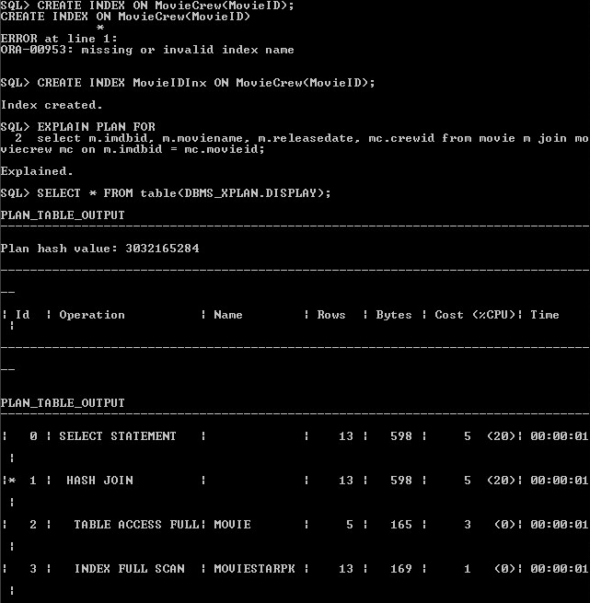

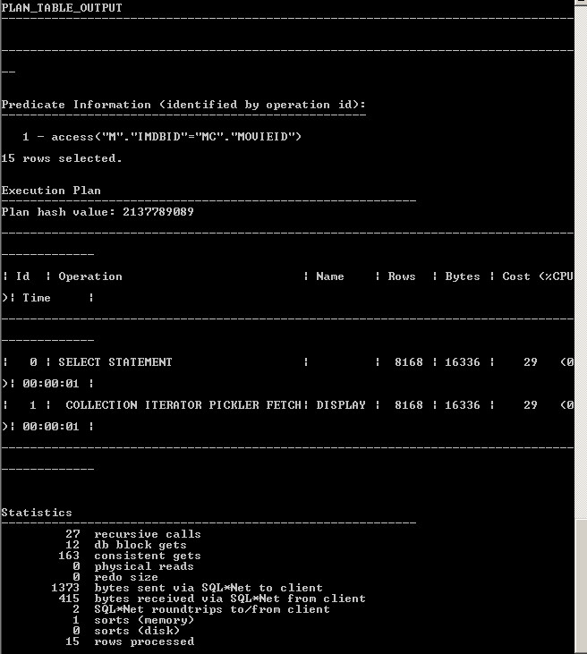

From the above result comparison, we can see after creating index, “recursive calls”, “consistent gets” and “sorts (memory)” has been reduced significantly.

In order to improve database performance, we’ll create indexes when they can speed up queries. EXPLAIN PLAN is good feature to determine how the indexes are used. Usually we create an index if we frequently want to retrieve less than 15% of the rows in a large table or on columns used for joins to improve performance on joins of multiple tables. We usually don’t create indexes on primary and unique keys as they already have indexes, but if they are foreign keys, we could try to create index. These are some guidelines in determining when to create an index that will be useful in reality.

# 18. Lessons Learned

1) Data modeling is in the earlier steps and is important for successful database construction. If data modeling is unmatched with the actual relationship can’t solve the problems efficiently, late modification would be difficult and consume a lot of time.

2) All the topics we learned in the class are useful in real database design. ADT, triggers, packages, forms and reports are contributing to business problem solving directly. Each of them is instrumental in helping with specific part. Without them, data management would be much harder and require much more manual labor. Tablespace, users, roles, profiles help with the database authentication and authorization and help ensure database security. Database backup/recovery help ensure stable database operation even under emergent cases. Performance monitoring and tuning help improve database performance and expedite business decision-making.

3) A database administrator needs to be good at logic thinking and familiar with all the database functionalities and tools so that s/he can easily make decision on which ones are better to use. A database administrator also needs to be considerate of every detail in the database design and implementation as each inappropriately handled detail would be related to potential problems. Patience is required while performing day to day administration tasks as errors in each step would result in problems that may not be easily detected.

4) Oracle database is very powerful in resolving data management problems. In my final project, all the business problems I’m concerned about can be resolved by Oracle database implementation. In real case, the data would come in large amount and be complicated that it’s hard to separate them into different logic units and relate them according to the business implication. With oracle, we can handle this situation efficiently and save a lot of manual labor than if the data processing is paper-based.

5) Database design needs to be as practical as possible. First, considerations such as the length we give to data fields sound like not a big issue at first, but it turns out to be of concern when users actually input data with much larger length. A big database could involve thousands of attributes, in that case it’s important for DBA for design the database as practical and usable as possible. Database Administrator need to have basic knowledge of what data s/he will encounter and design a corresponding system to that. The functionality design needs to be practical as well. Sometimes some functionalities would ameliorate the project but would consumer rather considerable efforts and resource and still are not cost-effective for us to build into database.